**CHAPTER I  
INTRODUCTION**

In today's dynamic business landscape, efficient inventory management is essential for ensuring operational efficiency and customer satisfaction. Traditional inventory tracking methods often fall short of providing real-time data accuracy and accessibility, leading to inefficiencies and errors. However, with the advent of QR code technology and informed mechanism-driven systems, there lies a transformative opportunity to revolutionize how organizations track and manage their equipment inventory.

QR code scanning has emerged as a powerful tool in inventory

management, offering a versatile and convenient solution for tracking assets. QR codes enable rapid and accurate identification of inventory items by encoding essential information into a compact visual format. When coupled with an informed mechanism-driven system, which leverages advanced data analytics and integration capabilities, QR code scanning becomes even more potent, facilitating seamless tracking and management of equipment across the supply chain.

This paper delves into the synergistic potential of QR code scanning and informed mechanism-driven equipment tracking systems. We explore how these technologies can be integrated to address common challenges in inventory management, such as data accessibility, accuracy, and scalability. Furthermore, we examine the implications of intuitive user interface design in enhancing.

**Context of the study**

The study focuses on implementing a QR code scanning system integrated with an informed mechanism to track equipment. This system likely aims to enhance equipment management and monitoring by utilizing QR codes as unique identifiers for each piece of equipment. The informed mechanism could involve gathering and analyzing data related to equipment usage, maintenance, and location to provide real-time insights and improve overall efficiency and accountability in the warehouse.

Additionally, the study might explore the technical aspects of implementing QR code scanning technology, such as the development of a mobile application or hardware devices capable of scanning QR codes. It could also delve into the design of the informed mechanism, including the algorithms and data analytic techniques used to process and interpret the collected data for tracking equipment effectively. Furthermore, the study may discuss the potential benefits of such a system, such as improved inventory management, reduced downtime, and enhanced safety protocols.

**Historical Background**

The General Service Office (GSO) used the traditional way of inventory which is a spreadsheet. The GSO typically relies on manual processes and basic tools.

Here are some traditional methods they commonly used until now:

Manual Tracking: This involves physically counting and recording inventory items on paper or in a spreadsheet. It's a labor-intensive process prone to human error.

Periodic Inventory Systems: In this method, inventory counts are conducted at regular intervals, such as weekly, monthly, or quarterly. It helps in updating inventory levels periodically but doesn't provide real-time data.

Pen and Paper: Before the digital age, inventory management relied heavily on pen and paper, where records were manually updated and maintained in ledger books.

These traditional methods have limitations such as inefficiency, inaccuracies, and lack of real-time data. Modern inventory management systems leverage technology, such as inventory management software, RFID (Radio Frequency Identification), and IoT (Internet of Things), to overcome these limitations and improve efficiency, accuracy, and visibility throughout the supply chain.

**Statement of the problem**

The General Services Office plays a crucial role in every organization, overseeing the management and maintenance of essential equipment necessary for daily operations. Despite its importance, the office faces several challenges that hinder its efficiency.

Below are the problems faced at the General Services Office:

1. Lack of Equipment accountability.
2. Keeping records manually and unsecured storage.
3. Difficulty in tracking equipment location.
4. Poor scheduling of equipment maintenance work.

**Objectives of the study**

The objective of this study is to provide a more efficient way of tracking the equipment in the General Services Office and mitigating its usage of spreadsheets. This system aims to transform how organizations track and manage their equipment by leveraging QR code technology and informed mechanism-driven approaches. By improving efficiency, accuracy, and security, this system is dignified to enhance overall operational effectiveness and streamline inventory management processes of the General Services Office of Bago City. Below are the specified objectives of the study:

1. To develop a system and implement a centralized system for tracking equipment location and status using technologies such as QR code scanning,
2. To develop a tracking system that will oversee all equipment records.
3. To develop authentication methods to verify the identity of users before granting access to the system.
4. To develop a system with features for scheduling and tracking maintenance tasks for equipment.

**Significance of the study**

This study is conducted to benefit the following:

## 1. General Services Office (GSO) in Bago City: The primary beneficiary would

be the GSO itself. Implementing the proposed QR Code Scanning with an Informed Mechanism Driven Equipment Tracking System would significantly improve their efficiency in managing and documenting inventory. This system would streamline their processes, reduce errors, enhance decision-making, and ultimately improve their service delivery to government entities and the public.

1. **Offices in Bago City**: Other government offices and departments that rely on

the services provided by the GSO would benefit indirectly. A more efficient inventory management system would ensure that they receive timely and accurate assistance from the GSO, improving overall government operations and service delivery.

1. **Future Researchers:** Future researchers in the field of inventory

management can benefit from this study as it provides a practical example of implementing a QR Code Scanning with Informed Mechanism Driven Equipment Tracking System. The study offers insights into the benefits, challenges, and best practices of such a system.

**Scope of the study**

In this part of our study lies the coverage of our system: what are the system's capabilities and to what extent can it do the tasks.

1. The system will focus on tracking inventory items using QR codes.
2. The system will feature alerts and notifications will be implemented for equipment’s life span, unauthorized access, and equipment maintenance.
3. The system will revolve around managing user roles and permissions specifically for inventory and equipment data access.
4. The system utilizes machine learning for real-time monitoring of inventory status, constantly checking and keeping an eye on the inventory as things change.
5. The system will focus on its fundamental objective, which is to manage the equipment in the inventory exclusively, without handling stocks.
6. The system will exclusively employ browser-based development

**Limitations of the study**

With all the coverage and capabilities of our study and our proposed system, it also has its limitations.

1. Not all users may have access to smartphones or devices capable of scanning QR codes.
2. The system will not be accessible without Internet.

**Conceptual Framework**

A conceptual framework for an equipment inventory tracking system aims to efficiently manage and track equipment to maximize usage and minimize loss. It includes inputs such as equipment details, tracking tags, user data, and technology. The processes involve data collection, management, real-time tracking, reporting, and auditing. Outputs consist of inventory reports, performance metrics, and alerts. The outcomes are improved equipment utilization, cost savings, informed decision-making, regulatory compliance, and enhanced accountability. Essentially, this framework organizes how inputs are processed to produce outputs that drive better management and operational efficiency.

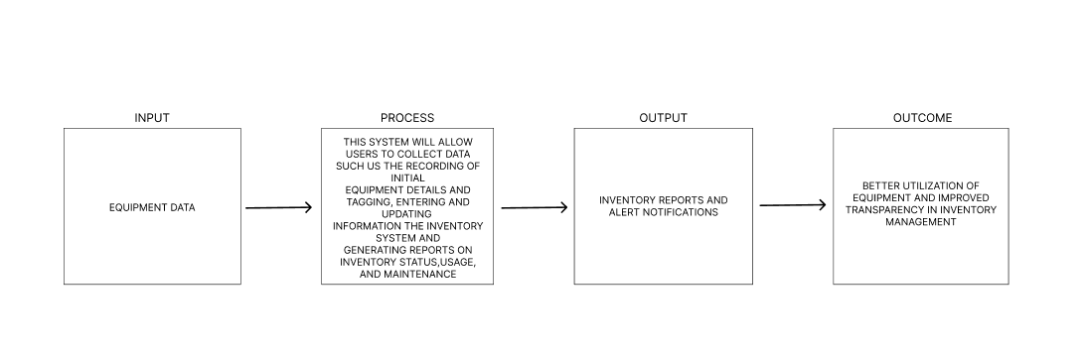

**Input**

Equipment data

**Process**

the system will allow users to collect data such as the recording of initial equipment details and tagging, entering and updating information in the inventory system, and generating reports on inventory status, usage, and maintenance.

**Output**

inventory reports and alerts notifications.

**Outcome**

better utilization of equipment and improved transparency in inventory management.

**CHAPTER II**

**LITERATURE REVIEW**

Inventory management systems are integral to the effective operation of businesses across various industries. Historically, these systems have evolved from manual methods to sophisticated technological solutions. Key concepts such as the economic order quantity (EOQ) model and just-in-time (JIT) inventory management have guided the development of inventory management practices.

Today, organizations utilize a range of systems including manual, barcode-based, RFID, and advanced software solutions like ERP systems to manage their inventory. These systems offer numerous benefits such as cost savings, improved accuracy, and better decision-making. However, challenges such as implementation costs and data security concerns persist. Case studies of companies like Amazon and Walmart showcase the positive impact of inventory management systems on operational efficiency and customer satisfaction. Emerging trends such as cloud-based systems and AI-driven analytics are shaping the future of inventory management. Despite advancements, there are still research gaps, particularly regarding the integration of emerging technologies and sustainability initiatives. Continued research in this field is crucial for addressing these gaps and maximizing the potential of inventory management systems.

**Related Concepts**

Inventory management systems adhere to key principles such as accuracy in record-keeping, real-time tracking of inventory movements, optimization of inventory levels to balance costs, forecasting and demand planning for future requirements, collaboration with suppliers for timely deliveries, automation of processes to streamline operations, risk management to mitigate potential disruptions, and a commitment to continuous improvement through feedback and data analysis. These principles collectively ensure efficient control and optimization of inventory, essential for success across various industries.

## **(Chopra & Meindl, 2019)**

Inventory management systems are guided by fundamental principles to ensure effective control and optimization of inventory levels. For instance, maintaining accurate inventory records is essential to prevent stockouts and overstocking. Real-time tracking capabilities enable timely decision-making and responsiveness to changes in demand or supply. Additionally, the optimization principle emphasizes the importance of balancing inventory holding costs with the costs of stockouts or backorders, aiming to maximize profitability. Forecasting and demand planning techniques, help anticipate future inventory requirements, while collaboration with suppliers facilitates timely deliveries and minimizes lead times.

Automation technologies streamline inventory management processes, reducing manual errors and enhancing efficiency. Moreover, risk management strategies. address potential inventory-related risks such as obsolescence and supply chain disruptions, ensuring continuity of operations. Finally, a commitment to continuous improvement fosters ongoing evaluation and optimization of inventory management practices, driving operational excellence and sustained competitive advantage. These principles collectively underpin the effective functioning of inventory management systems across diverse industries. **(Jacobs, Chase, and**

## **Aquilano 2017)**

The concept of QR code scanning within an informed mechanism-driven equipment tracking system is related to several areas, including supply chain management, asset tracking, and Internet of Things (IoT) technologies. Here's a breakdown of related concepts along with relevant citations:

1. Supply Chain Management (SCM):

QR code scanning can streamline inventory management and logistics within the supply chain. It allows for real-time tracking of products and assets, improving efficiency and reducing errors. Research on Application of QR Code Technology in Food Supply Chain Traceability. In 2017 International Conference on Service Systems and Service Management (ICSSSM) (pp. 1-6). IEEE.

## **(Liu, S., & Wang, Y. 2017)**

library sector. Together, these developments underscore the critical role of ILMS in facilitating access to information, enhancing user engagement, and promoting lifelong learning in modern libraries.

2. Asset Tracking:

Implementing QR codes for equipment tracking enables organizations to monitor the movement and usage of assets more effectively. This is particularly useful in industries like manufacturing, healthcare, and construction.

IoT-based Asset Tracking and Management System. In 2020 11th International

Conference on Computing, Communication, and Networking Technologies

## **(INT) (pp. 1-5). IEEE. - (Mahato, N., & Pradhan, R. K. 2020)**

3. Internet of Things (IoT):

Integrating QR Code scanning with IoT devices enhances the capability to collect and process data about equipment status and location. This allows for more intelligent decision-making and predictive maintenance. (**Atzori, L., Iera,**

## **A., & Morabito, G. 2010)**

4. Data Analytics and Machine Learning:

Utilizing data collected from QR code scans and equipment tracking systems can enable predictive analytics and machine learning algorithms to optimize resource allocation and prevent failures. **(Zhang, Y., Zheng, Y., & Xie,**

## **X. 2016)**

5. Security and Privacy:

Implementing QR code scanning systems requires attention to security and privacy concerns, such as data encryption, access control, and compliance with regulations like GDPR. **(Zhang, Y., & Zhang, Y. 2017).**

**Related Works**

## **Smart Inventory Management System (SIMS)**

The development of IoT-based low-cost smart inventory management systems has gained significant attention in recent years due to their potential to improve inventory efficiency and reduce operational costs. One such system utilizes data and software to effectively manage inventory levels, orders, and deliveries. By saving product data, locating items, and issuing alerts for stock discrepancies, SIMS streamlines inventory management processes, thereby reducing expenses, time, and complexity associated with traditional inventory management methods **(TUSHAN S, Muntasir A, Muhiminul Haider A, Hasan**

**Mojumder M, Easanul Alam A, Islam Bappy S, Rahman A, Sami S, December 2022).**

## **Effective Inventory Control System**

Effective inventory control systems are essential for optimizing warehouse operations, reducing costs, and expanding profit margins. The Application Inventory Control System in Warehouse highlights the importance of implementing robust inventory control systems and strategies. This includes optimizing batch quantities, refining ordering procedures, and implementing inventory classification methods to enhance operational effectiveness and maximize profitability **(Phindile Ndlala, C. Mbohwa 2017).**

## **Asset Tracking System**

Asset Tracking Systems: Readiness and selection factors RFID (radio frequency identification) technology is a new technology that several hospitals have been considering. The technology can be used to locate equipment required for clinical procedures as well as to track down medical devices that require inspections or repairs. Asset tracking is the process of identifying, locating, and detecting assets (such as specific medical equipment) very instantly while also keeping track of the assets' actual positions over time (**James P. Keller, Jr. MS, 2007).**

## **Web-based Intelligent Inventory**

The development of web-based intelligent inventory management systems offers a scalable and efficient solution for coordinating inventory operations across multiple establishments. By leveraging technologies such as MySQL, HTML, JavaScript, PHP, and Xampp (Apache), these systems can integrate diverse inventory management functions and provide real-time supply status updates. By transitioning from single-store to distributed systems, businesses can maximize inventory performance and improve overall operational efficiency **(Daramola Oa, .G AkintolaK, Olugbenga Ayomide Madamidola, 2017).**

## **Barcode Technology System**

Barcode technology has revolutionized warehouse management systems by providing a reliable and efficient method for tracking inventory items throughout the supply chain. The Implementation of Barcode on Warehouse Management System explores how incorporating barcode technology into warehouse processes can reduce errors, deliver accurate real-time data, and streamline operations. By leveraging barcode technology, businesses can increase warehouse productivity and improve inventory accuracy **(Nadya Amanda Istiqomah, Putri Fara Sansabilla, Doddy Himawan, M. Rifni 2020).**

**Related Tools**

**PHP** is a server-side scripting language used for web development to create dynamic web pages and web applications. It can interact with databases, handle forms, manage sessions, and perform various server-side tasks.

**JavaScript** is a client-side scripting language used primarily for enhancing web pages with interactivity and dynamic behavior. It allows developers to manipulate HTML and CSS, handle events, create animations, and interact with the browser's Document Object Model (DOM).

**CSS (Cascading Style Sheets)** is a style sheet language used to define the presentation of HTML and XML documents. It controls the layout, appearance, and visual formatting of web pages, including elements such as colors, fonts, margins, and spacing.

**HTML (Hypertext Markup Language)** is the standard markup language for creating web pages and web applications. It defines the structure and content of a web page using a system of tags and attributes to specify elements such as headings, paragraphs, links, images, and forms.

**Visual Studio Code (VS Code)** is a lightweight, open-source code editor developed by Microsoft. It supports various programming languages and features built-in support for debugging, syntax highlighting, code completion, version control

integration, and an extensive library of extensions to enhance functionality and customization. It's widely used by developers for web development, but it's versatile enough for other types of programming as well.

**MySQL** is a popular open-source relational database management system (RDBMS) that uses structured query language (SQL) for managing and manipulating data. It is commonly used for building and managing databases for web applications, content management systems, and various other types of software. MySQL is known for its reliability, scalability, and ease of use.

**XAMPP** is a free and open-source cross-platform web server solution stack package developed by Apache Friends. The name is an acronym, with "X" standing for cross-platform, "Apache" for the Apache HTTP Server, "MySQL" for the MySQL database, "PHP" for the PHP programming language, and "Perl" for the Perl programming language. XAMPP is designed to simplify the process of setting up a local development environment for web development. It includes all the necessary components (Apache, MySQL, PHP, and Perl) bundled together in a single package, making it easy to install and configure on Windows, macOS, and Linux systems. XAMPP allows developers to create and test web applications locally before deploying them to a live server.

**Synthesis**

Integrating QR code scanning within an informed mechanism-driven equipment tracking system presents a multifaceted approach to enhancing inventory management and operational efficiency across various industries. By leveraging QR code technology, organizations can streamline the tracking of equipment movements and status updates, ensuring real-time visibility into inventory levels and location data. This integration facilitates accurate recordkeeping and enables prompt decision-making, ultimately reducing the risk of stockouts and optimizing inventory levels. Moreover, coupling QR code scanning with informed mechanism-driven tracking systems empowers businesses to implement predictive maintenance strategies, leveraging data analytics and machine learning algorithms to anticipate equipment failures and schedule preventive maintenance activities proactively. This proactive approach not only minimizes downtime but also extends the lifespan of equipment, enhancing overall productivity and cost-effectiveness. Additionally, the integration of QR code scanning within the tracking system enables seamless collaboration with suppliers, facilitating timely replenishment of inventory and minimizing lead times. Furthermore, by embracing a culture of continuous improvement, organizations can iteratively enhance their inventory management practices, leveraging feedback and data analysis to drive operational excellence and sustain competitive advantage in the dynamic marketplace. In essence, QR code scanning within an informed mechanism-driven equipment tracking system represents a holistic solution for optimizing inventory management processes, enhancing operational efficiency, and fostering innovation in modern business.

**CHAPTER III  
METHODOLOGY**

In Chapter III, an in-depth exploration is conducted into the research methodology within the framework of Scrum, emphasizing its applicability across both the model base and model phase. This chapter integrates Scrum’s renowned adaptability and iterative approach, strategically aligning it with the defined research objectives. Within the model phase, the principles of Scrum serve as guiding principles for crucial aspects such as data collection methodologies, sampling strategies, and analytical frameworks. These elements are structured around key Scrum events including Sprint Planning, Daily Stand-ups, Sprint Reviews, and Sprint Retrospectives, ensuring a systematic and transparent progression of the research endeavor.

Furthermore, the chapter deliberates on the meticulous selection of appropriate methods and tools, meticulously chosen to ensure feasibility and alignment with the unique nuances of the research context. This deliberate methodological approach not only bolsters the credibility of the findings but also fortifies the overall rigor of the research process. By leveraging the principles of Scrum, Chapter III lays a robust foundation that enhances the integrity and comprehensiveness of the ensuing research outcomes, thereby enriching

scholarly discourse within the field.

**Model Base**

## Scrum, renowned for its structured framework adaptable to various fields beyond software development, is increasingly valued for its effectiveness in research and academia. Our study leverages Scrum principles within the model base to cultivate a collaborative environment where transparency and iterative progress are prioritized. By embracing Scrum's methodology, we aim to streamline data collection, sampling, and analysis, aligning each step with key Scrum events like Sprint Planning and Sprint Reviews. This approach ensures systematic and transparent research advancement, enhancing both the reliability and credibility of our findings. Ultimately, integrating Scrum into our research methodology provides a robust framework that promotes efficiency and accountability throughout the research process.

**Scrum Framework**

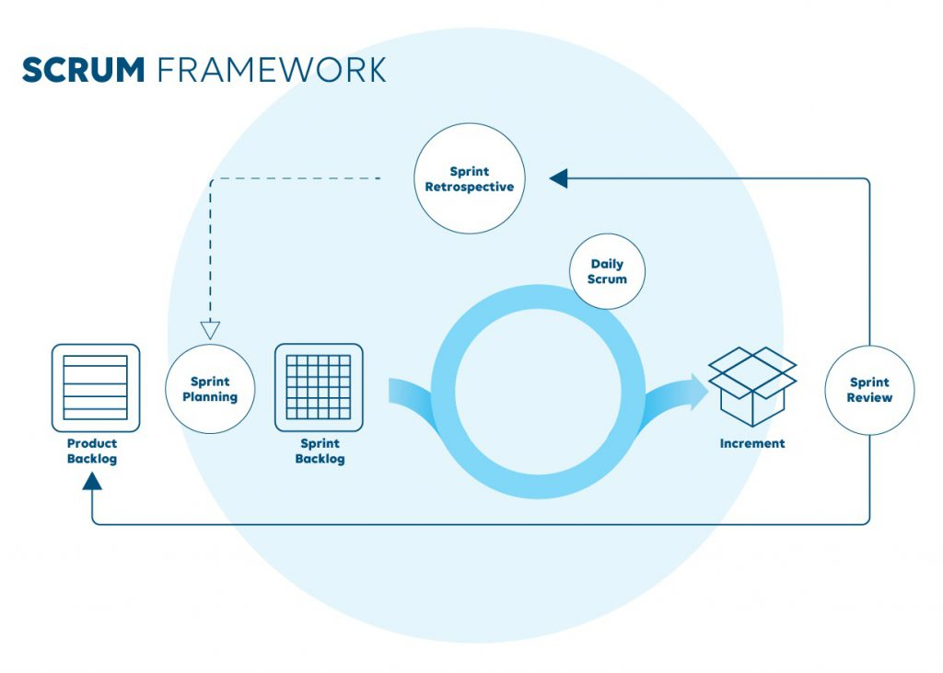

Figure 3.1 Agile Methodology

Scrum, known for its structured approach adaptable beyond software development, is increasingly recognized for its effectiveness in diverse fields, including research and academia. In our study, we employ Scrum principles within our model to foster collaboration and emphasize transparency and iterative progress. By embracing the methodology of Scrum, our goal is to streamline the processes of data collection, sampling, and analysis, ensuring each phase aligns with key Scrum events such as Sprint Planning and Sprint Reviews. This structured approach facilitates systematic and transparent advancement in our

research, significantly bolstering the reliability and credibility of our findings. Ultimately, integrating Scrum into our research methodology provides a robust framework that enhances efficiency and accountability throughout the entire research endeavor, contributing to a more rigorous and comprehensive scholarly exploration.

**Model Phase**

In the contemporary landscape of technological advancements, the integration of QR code scanning within equipment tracking systems has revolutionized asset management across various industries. QR codes, or Quick Response codes, are two-dimensional barcodes that store information in a machine-readable format. When combined with informed mechanism-driven equipment tracking systems, they offer a robust solution for real-time monitoring, asset management, and data accuracy.

This model phase introduction aims to provide a comprehensive overview of the integration of QR code scanning with informed mechanism-driven equipment tracking systems. The focus will be on the mechanisms involved, the benefits, and the potential applications across different sectors.

**Phase 1: Product Backlog Refinement**

## 

In the product backlog refinement for our capstone project on QR code scanning with an informed mechanism-driven equipment tracking system, our team will first review and ensure all backlog items are well-defined and clear. Next, prioritize these items based on their importance, urgency, and dependencies, while clarifying any requirements and misunderstandings. Use techniques like Planning Poker to estimate the effort required for each item, and break down larger tasks into smaller, manageable ones. Update the acceptance criteria to be clear, measurable, and testable, and add any necessary details such as wireframes or diagrams. Review and document dependencies between tasks and ensure top-priority items meet the Definition of Ready (DoR) criteria for the next sprint. Schedule regular refinement sessions with our team to keep the backlog dynamic and up-to-date. Specific considerations include defining and prioritizing features for QR code generation and scanning, clarifying the informed mechanism for notifications and alerts, breaking down the equipment tracking system into core components like database setup and user interface, and ensuring seamless integration and thorough testing. Regular updates, continuous stakeholder collaboration, and focus on value delivery are crucial throughout the process

**Phase 2: Sprint Planning**

For our capstone project, which involves scanning QR codes using an informed mechanism-driven equipment tracking system, we will first analyze the backlog items that have been prioritized and made ready for the sprint. Work together as a team to determine which of the most important tasks can be accomplished in the allotted sprint time. Divide these chosen items into more manageable tasks and subtasks, making sure that each is precisely specified and allocated to team members. Make sure the acceptance criteria are precise, quantifiable, and testable by having a discussion and confirming them for each item. As a team, estimate how much work each task will demand and how much we can do to make sure the workload is achievable. Plan ways to mitigate any possible hazards or dependencies that could affect the sprint and address them.

Establish specific objectives for the sprint and specify what will be considered successful when it is all over. Throughout the sprint, we make sure there is constant communication and teamwork to adjust to any obstacles or changes that may occur. We can make sure the sprint is well-organized, targeted, and in line with the project objectives by following these procedures

**Phase 3: Daily Stand-ups**

During the daily standup phase for our capstone project on QR code scanning with an informed mechanism-driven equipment tracking system, the team will have a brief meeting (about 15 minutes) where each member answers three key questions: what they did yesterday, what they will do today, and any impediments in their way. This ensures everyone stays informed about progress, plans for the day, and any obstacles that need addressing. The focus is on communication, transparency, and collaboration, helping the team stay synchronized, promptly address issues, and keep the project moving forward efficiently.

**Phase 4: Sprint Review**

During the sprint review phase for your capstone project on QR code scanning with an informed mechanism-driven equipment tracking system, the team will demonstrate the work completed during the sprint to stakeholders. This involves showcasing the new features or improvements, such as QR code scanning functionalities, informed mechanisms for notifications, and updates to the equipment tracking system. Stakeholders provide feedback on the work, discussing what was successful and what could be improved. The team reviews functionalities.

whether the sprint goals were met and reflects on any changes or adjustments needed for future sprints. This phase focuses on ensuring that the delivered product meets stakeholder expectations and aligns with project goals, while also gathering insights to refine the backlog and plan for subsequent sprints.

## **Phase 5: Sprint Retrospective**

During the sprint retrospective phase for our capstone project on QR code scanning with an informed mechanism-driven equipment tracking system, the team will gather to reflect on the completed sprint. The focus is on identifying what went well, what didn't go well, and what can be improved. Team members discuss specific aspects of the sprint, such as the effectiveness of collaboration, the efficiency of processes, and the quality of the deliverables. We also consider any obstacles encountered and how we were addressed. The goal is to identify actionable improvements that can be implemented in the next sprint to enhance productivity and teamwork. By fostering open communication and continuous improvement, the sprint retrospective helps the team refine our workflow, adapt to challenges, and maintain a high standard of performance throughout the project.

## **Phase 6: Increment**

During the increment phase for our capstone project on QR code scanning with an informed mechanism-driven equipment tracking system, the team focuses on delivering a potentially shippable product increment at the end of each sprint. This increment includes all completed features and improvements that have been thoroughly tested and meet the defined acceptance criteria. The increment should be fully integrated, ensuring that all components work seamlessly together, such as the QR code scanning, notification mechanisms, and equipment tracking functionalities. The team demonstrates the increment to stakeholders, highlighting how the new features contribute to the overall project goals. This tangible progress helps stakeholders understand the project's current state and provides a basis for feedback. The increment should be usable and provide value to the end-users, even if not all planned features are complete.

The goal of the increment phase is to ensure continuous delivery of value, enabling regular feedback loops, and validating that the project is on the right track. By focusing on creating a potentially shippable product increment, the team ensures steady progress, high quality, and alignment with stakeholder expectations throughout the project lifecycle.

**Validity and Reliability of the Research Instrument**

The research instrument for evaluating the integrated library management system with machine learning and QR code scanning was developed with clear objectives and validated using expert reviews and statistical methods. The tool demonstrated strong content and construct validity, effectively measuring relevant features such as system performance, user satisfaction, and integration effectiveness. With high reliability scores for internal consistency and test-retest stability, the instrument ensures that the data collected is both accurate and consistent, providing valuable insights for enhancing the LMS.

Table 1 – Validation and Reliability Instrument

**Table 1.1: System Performance Survey**

|  |  |  |
| --- | --- | --- |
| Dimensions | Survey item | Response (1-5) |
| Operational Efficiency | The system accurately tracks and updates library materials. |  |
|  | The integration of machine learning improves search functionality. |  |
| User Satisfaction | The QR code scanning feature is user-friendly and reliable. |  |
|  | The machine learning algorithms effectively recommend relevant materials. |  |
| Integration Effectiveness | The LMS integrates smoothly with existing library systems |  |
|  | The system’s performance meets the expected standards. |  |

**Table 1.2: System Usability Survey**

|  |  |  |
| --- | --- | --- |
| Dimensions | Survey Item | Response (1 – 5) |
| Ease of Use | The LMS interface is intuitive and easy to navigate. |  |
|  | QR code scanning is quick and accurate. |  |
| Technical Performance | The system operates efficiently without significant downtime. |  |
|  | Machine learning features provide accurate and timely recommendations. |  |
| User Support | Technical support responds promptly to issues. |  |
|  | Documentation and training materials are clear and helpful. |  |

**Table 2 – Expert Validation Result**

|  |  |  |  |
| --- | --- | --- | --- |
| Survey Item | Relevance (1-5) | Clarity (1-5) | Suggestions for  Improvements |
| System Performance |  |  |  |
| The system accurately tracks and updates library materials. |  |  |  |
| The integration of machine learning improves search functionality. |  |  |  |
| The QR code scanning feature is user-friendly and reliable. |  |  |  |
| The machine learning algorithms effectively recommend relevant materials. |  |  |  |
| Integration Effectiveness |  |  |  |
| The LMS integrates smoothly with existing library systems. |  |  |  |
| The system’s performance meets the expected standards. |  |  |  |
| Usability |  |  |  |
| The LMS interface is intuitive and easy to navigate. |  |  |  |
| QR code scanning is quick and accurate. |  |  |  |
| The system operates efficiently without significant downtime. |  |  |  |
| Machine learning features provide accurate and timely recommendations. |  |  |  |
| Technical support responds promptly to issues. |  |  |  |
| Documentation and training materials are clear and helpful. |  |  |  |

**Reliability of the Test**

The evaluation tool for the integrated library management system (ILMS) demonstrates strong reliability, highlighted by high internal consistency, stable test-retest reliability, and solid inter-rater reliability. Internal consistency is confirmed with a Cronbach’s alpha coefficient exceeding 0.70, indicating that the items consistently measure the key constructs of the ILMS. Test-retest reliability is also high, with a strong correlation between results from tests conducted at different times, ensuring the tool’s stability over time. Additionally, inter-rater reliability is robust, showing strong agreement among different evaluators’ scores, thus reinforcing the tool's consistency and dependability in assessing the ILMS.

**CHAPTER IV**

# ENVIRONMENTAL CONTEXT

This chapter provides an overview of the General Services Office (GSO), detailing its organizational structure, roles, and responsibilities within the organization. It also discusses the data formats used by the GSO and the methods employed for producing reports. Understanding these aspects of the GSO is crucial for comprehending its operations and the context in which the proposed system will be implemented. To effectively fulfill its myriad responsibilities, the GSO typically adopts a hierarchical organizational structure tailored to the specific needs and complexities of the organization it serves. At the apex of this structure is the GSO Director or Manager, tasked with providing strategic direction and oversight to the department. Reporting to the director are various teams or units, each specializing in distinct facets of general services management. These may include facilities management, procurement, transportation, and administrative support, among others. By delineating responsibilities and establishing clear lines of communication, this hierarchical structure enables the GSO to streamline operations and respond promptly to organizational needs.

**Organization**

The General Services Office (GSO) is one of the departments in Bago City Mechanism. The General Service Office is responsible for managing facilities, handling procurement and contracts, providing transportation services, overseeing mail and courier services, managing office supplies and equipment, coordinating events and meetings, and sometimes providing additional administrative support.

A General Service Office Designate, Supply Management Section, Supply Officer, and Warehouseman who are in charge of a particular window make up this structure. For the organization to remain in balance and harmony, they each have certain jobs and tasks to carry out. The General Services Office Bago is one of the busiest offices since it stores and tracks the types of equipment. They handle each transaction manually, which is problematic, especially if there are to many equipment that they need to track in every office.

**Organizational Chart**

Figure 4.1 Organizational Chart

**City Government Department Head**

The City Government Department Head is the executive leader of the General Services Office, tasked with overseeing all departmental functions and ensuring alignment with the city's strategic objectives. This role involves high-level decision-making, budget management, and policy formulation to drive departmental efficiency and effectiveness.

**Administrative Section**

The Administrative Section is responsible for the essential clerical and administrative functions that support the overall operations of the General Services Office. This includes maintaining accurate records, managing correspondence, scheduling meetings, and ensuring efficient office procedures. The section plays a crucial role in facilitating communication within the department and with external stakeholders, thereby enhancing operational efficiency.

**Motorpool Management Section**

Motorpool Management Section oversees the department’s fleet of vehicles, ensuring they are well-maintained and efficiently utilized. This section is responsible for scheduling vehicle use, conducting regular maintenance checks, and managing repairs to minimize downtime. By ensuring the availability and reliability of vehicles, the section supports the transportation needs of various departmental operations and city services.

**Warehouse**

The Warehouse section is tasked with the management of all stored goods, including the receipt, storage, and distribution of supplies and equipment. It ensures that inventory levels are adequately maintained and that items are properly tracked and accounted for. The Warehouse plays a vital role in supporting the logistical needs of the department by ensuring timely and accurate supply chain operations.

**Supply and Property Management Section**

This section is responsible for the procurement, management, and disposal of departmental supplies and properties. It ensures that all acquisitions are made in compliance with relevant regulations and that inventory is effectively managed to support departmental needs. Additionally, the section oversees the maintenance and optimal use of properties, ensuring they remain in good condition and are utilized efficiently.

programming for children and teens, while reference specialists aid patrons with research and information literacy. Technology specialists oversee digital resources and infrastructure, and community engagement coordinators connect the library with the community through events and outreach. Administrative and support staff assist with clerical tasks and management support. Each staff member contributes expertise to fulfill the library's mission of providing information, education, and cultural enrichment to the community, making them essential to the library's impact and relevance within the city.

**General and Special Events Assi: stance Section**

The General and Special Events Assistance Section provides logistical and operational support for events organized by the city or department. This includes planning, coordinating, and managing resources to ensure successful event execution. The section's work ensures that events run smoothly, enhancing community engagement and supporting the city's public relations efforts.

**Property and Facility Management Section**

The Property and Facility Management Section is tasked with the upkeep and maintenance of all departmental properties and facilities. This includes managing repairs, overseeing renovations, and ensuring compliance with safety regulations. By maintaining a safe and functional environment, the section ensures that facilities support the department's operational needs and the well-being of its employees.

**Processes**

Every acquisition of equipment is carefully watched over and investigated, and the entire procurement procedure is examined. To monitor the equipment's location and condition, the following procedures are followed:

Step 1: A department or user identifies the need for new equipment or replacement of existing equipment.

Step 2: The specific requirements and justifications for the equipment are documented.

Step 3: The purchase request will be made.

Step 4: The request will be received by the GSO.

Step 5: The request is routed to the requester's immediate supervisor for initial review and approval.

Step 6: Upon supervisor approval, the request is forwarded to the department head for further review.

Step 7: The request is then sent to the finance department to ensure budget availability and compliance with financial policies.

Step 8: Once the supplier is selected, the organization waits for the delivery of the equipment.

Step 9: Ensures the requested equipment complies with organizational standards and policies.

Step 10: Select the best supplier for the equipment based on their price, quality, life span considerations.

Step 11: Once the supplier is selected, the organization waits for the delivery of the equipment.

Step 12: The warehouse will receive the equipment.

Step 13: Deliver it to the end user who will be given an inventory custodian slip. Step 14: The end user will inform the office of the GSO that they have received the equipment, and notify them for further notice about the equipment status.

Step 15: Print out the report on the equipment.

**Data**

Data, in its myriad forms, is the backbone of information systems across various domains. It can be as simple as texts or numbers meticulously inscribed on paper or as complex as the intricate patterns of bytes and bits residing within the memory of electronic devices. Furthermore, data can also encompass intangible facts and knowledge stored within the human mind, a repository of immense potential. The significance of data becomes particularly evident when considering the academic sphere, where the data about students is of paramount importance. Each piece of information gathered during academic transactions forms a crucial component of the broader educational ecosystem.

In the context of educational institutions, various documents and records serve as vital repositories of data. For instance, the Inventory Custodian Slip,

Property of Waste Materials, and the Report on the Physical Count of Property, Plant, and Equipment are essential documents that encapsulate valuable information. The data captured within these documents is integral to maintaining the operational efficiency and integrity of the institution. These documents are not merely records; they are a reflection of the meticulous processes involved in managing and safeguarding institutional assets.

1. **Inventory Custodian Slip** is a document used to track the transfer or allocation of inventory equipment to an individual or department. It serves as a record of the equipment being entrusted to a particular custodian or custodial department.

Figure 4.2 Inventory Custodian Slip

**2. Report of Waste Material (Equipment)** focuses on the disposal or management of waste materials related to equipment used within an organization. This could include various types of equipment, such as machinery, electronics, appliances, vehicles, or other assets. A close-up of a paper

Figure 4.3 Report of Waste Material (equipment)

**3. Report on the Physical Court of Property, Plant, and Equipment** document that provides detailed information about the inventory and condition of tangible assets owned and utilized by an organization. This report is typically prepared by the finance or accounting department in collaboration with the operations or facilities management team.

Figure 4.4 Report on the Physical Count of Property, Plant and Equipment

**Technology**

Innovation is the persistently creating aftereffects of aggregated information what's more, application in all strategies, abilities, techniques, and cycles utilized in modern creation and logical examination. Any problem can be solved by utilizing machines, tools, strategies, systems, and procedures. The Bago City General Services Office uses the following manual process:

1. **Spreadsheet**: This is a digital tool used for data organization and analysis. It allows companies to track various metrics, perform calculations, and visualize data. It's essential for financial planning, project management, and decision-making processes.
2. **Ballpens**: These are fundamental tools for writing, which is necessary for notetaking, signing documents, and other manual record-keeping tasks.
3. **Bond paper**: This is a high-quality durable writing paper, used in many office settings. It's used for printing documents, letters, reports, and for note-taking.
4. **Stamp**: Stamps are used to mark documents with specific company information, like the company's name or address, or to signify approval or completion of certain tasks.
5. **Stapler**: This is used to bind pages together, making it easier to organize and manage documents.
6. **Puncher** (or hole punch): This tool is used to create holes in papers so they can be stored in binders or file folders, aiding in document organization.
7. **Folders**: These are used to store and organize documents, making it easier to retrieve and reference them later. They can be physical folders for paper documents or digital ones for electronic files.
8. **Computers**: Computers are essential tools in modern-day companies. They enable employees to perform a wide range of tasks, including word processing, data analysis, communication, and research.
9. **Printer**: Printers are used to produce hard copies of digital documents. They allow companies to create physical copies of reports, contracts, marketing materials, and other important documents.
10. **Clip**: Clips, such as paper clips or binder clips, are used to hold papers together. They are particularly useful for temporarily organizing documents or keeping related pages together. Clips help prevent papers from getting lost or mixed up, providing a simple and effective way to keep materials organized.

**Information**

As per the guidelines set by the General Services Office (GSO), the end user must complete a hard copy of the equipment request form and submit to the Department Head for approval. This meticulous process ensures that each equipment request originating from the GSO is meticulously documented and authorized by the appropriate personnel before any procurement or delivery processes are initiated. Such strict adherence to protocol helps maintain transparency, accountability, and efficiency in the equipment acquisition process, ultimately contributing to the organization's overall operational effectiveness.

The proposed system is designed to replace the manual procedures currently employed at the General Services Office with an automated system. Its primary objective is to enhance the speed and accuracy of the office's manual procedures. The implementation of this system is expected to assist the General Services Office in maintaining more accurate and reliable records, while also reducing the likelihood of accidental deletions of existing records and minimizing inaccuracies in report outcomes. This transition from manual to automated processes is aimed at streamlining operations, ultimately leading to improved efficiency and reliability in managing records and generating reports for the

General Services Office.

**Report on the Physical Count of Property, Plant and Equipment**

Figure 4.5 (Report on the physical count of property, plant, and equipment)

**

Figure 4.6 Report of Waste Materials

**CHAPTER V**

**REQUIREMENTS ANALYSIS AND SPECIFICATION**

This system must be meticulously designed to meet the unique demands of the GSO, focusing primarily on equipment inventory management. The system should prioritize features such as real-time monitoring, accurate tracking, and automated notifications for maintenance and replenishment.

In the fast-paced and dynamic environment of educational institutions, efficient management of resources is paramount to ensuring smooth operations and optimal utilization of assets. The General Services Office (GSO) at Bago City College plays a pivotal role in this regard, serving as the custodian of various equipment and resources essential for the institution's functioning. Recognizing the need for enhanced efficiency and accountability in equipment inventory management, the GSO has embarked on the development of a sophisticated QR code scanning equipment tracking system. This system represents a significant advancement in the GSO's operational capabilities, leveraging technology to streamline inventory management processes and ensure the seamless provision of essential resources.

**Technical Requirements**

T he system requires the following hardware and software for the Sever, the

Supply Management Team and Warehouseman that will use the proposed system. To ensure the successful deployment and operation of the proposed system, it is imperative to outline the necessary hardware and software specifications for all stakeholders involved. This includes the server infrastructure, the Supply Management Team, and the warehouse personnel. Each of these components plays a crucial role in the seamless functionality and efficiency of the system, thereby necessitating a thorough consideration of their technical requirements. The server serves as the backbone of the entire system, hosting critical applications, databases, and services that facilitate real-time operations and data management. Given its central role, the server must possess robust hardware capabilities to handle high volumes of transactions, ensure data integrity, and provide rapid response times. Additionally, the server's software environment must be stable, secure, and scalable to accommodate future growth and evolving business needs.

**Server**

**l. Hardware Requirements**

|  |  |  |
| --- | --- | --- |
| **Components** | **Minimum Requirements** | **Justification** |
| Processor | Intel Core i5-  8100H | Responds to and processes the basic instructions that drive a computer. The CPU is seen as the main and most crucial integrated circuitry (IC) chip in a computer, as it is responsible for interpreting most of computer commands. |
| RAM | 32GB | RAM in a PC can significantly enhance its performance. This includes faster boot-up and shutdown times, as well as smoother program launches and task executions |
| Network | LAN | Transmitting, exchanging or sharing data and resources through WIFI or cables. |
| Monitor | Any monitor | Use to display information in pictorial or textual form. |
| Mouse | Any mouse | To point at an object you see on the screen. |
| Keyboard | Any keyboard | Putting information including letters and numbers on your computer. |

**ll. Software Requirements**

|  |  |  |
| --- | --- | --- |
| **Components** | **Minimum Requirements** | **Justification** |
| Operating System | Windows Server or  Linux distribution  (such as Ubuntu  Server or CentOS) | Commonly used version of an operating system of Server on Windows |
| Xampp | 8.1.4 (Apache,  MySQL) | Use to host data base and Apache |
| Browser | Google Chrome,  Firefox | Safer to use in accessing links or website |

**Users**

1. **Hardware Requirements**

|  |  |  |
| --- | --- | --- |
| **Components** | **Minimum Requirements** | **Justification** |
| Processor | Intel Core i5-  8100H | Responds to and processes the basic instructions that drive a computer. The CPU is seen as the main and most crucial integrated circuitry (IC) chip in a computer, as it is responsible for interpreting most of computer commands. |
| RAM | 32GB | RAM in a PC can significantly enhance its performance. This includes faster boot-up and shutdown times, as well as smoother program launches and task executions |
| Network | LAN | Transmitting, exchanging or sharing data and resources through WIFI or cables. |
| Monitor | Any monitor | Use to display information in pictorial or textual form. |
| Mouse | Any mouse | To point at an object you see on the screen. |
| Keyboard | Any keyboard | Putting information including letters and numbers on your computer. |

**II. Software Requirements**

|  |  |  |
| --- | --- | --- |
| **Components** | **Minimum Requirements** | **Justification** |
| Operating System | Windows  Server or Linux distribution  (such as  Ubuntu Server or CentOS) | Commonly used version of operating system of Server on windows |
| Browser | Google  Chrome,  Firefox | Safer to use in accessing links or website |

**System Facilities and Features**

**Admin**

1. Login

2. Equipment Transfer

A. Search Employee ID

B. View Custodian Records

3. Analytics

A. Generate Insights and trends from equipment usage and user activations.

4. Transactions Log

A. Generate inventory records

B. View Transaction Logs

5. Employee List

A. Search Employee ID

B. Can see if the employee is online or offline\

C. View records

6. Purchase Request

A. Can see the client’s request

7. Notification

A.

8. Settings

A. Update Profile

B. Change Password

9. Log out

**Finance Department**

1. Login

2. Dashboard

3. Purchase Request

A. Can see employee request

4. Notification

5. Settings

A. Update Profile

B. Change Password

6. Logout

**Department Head**

1. Login

2. Dashboard

3. Purchase Request

A. Can see employee request

4. Notification

5. Settings

A. Update Profile

B. Change Password

6. Logout

**Storekeeper**

1. Login

2. Dashboard

A. View the total number of end-users

B. Search total end-user and equipment

3. QR Code Scanning

A. Scan Code

B. Generate Code

C. View Records

4. Notification

5. Settings

A. Update Profile

B. Change Password

6. Logout

**Client**

1. Login

2. Purchase Request

A. Request Form

B. View request on the dashboard

3. Accountability

A. View order

4. Notification

5. Settings

A. Update Profile

B. Change Password

6. Logout

**Data Requirements**

Inventory Custodian Slip

1. Quantity - refers to the number of individual items or equipment.
2. Unit – refers to a single instance or individual equipment of a particular entity.
3. Description - a concise summary detailing the characteristics, specifications, and relevant information about the equipment
4. Life span of the equipment - refers to the projected duration over which an asset is expected to remain economically viable and operational for its intended purpose, as determined by analysis or industry standards.
5. Department Allocation - This term indicates the assignment of resources, tasks, or responsibilities to specific departments within an organization.
6. Person Assigned - an individual who has been designated or allocated a particular piece of equipment.

**Information Requirements**

1.Inventory Custodian Slip - contains all the transaction that happened in the

Equipment Tracking.

This includes the following:

* Document or form used to track the transfer or assignment of responsibility for a specific item or inventory asset to a designated custodian
* Serves as a record of accountability and helps ensure proper management and oversight of inventory within an organization.
* In the event of disputes or discrepancies involving inventory, the custodian slip can serve as evidence of ownership, custody, and chain of custody, offering legal protection to the organization.
* The slip facilitates the tracking of inventory items throughout their lifecycle, from acquisition to disposal, by recording custodian transfers and any relevant information such as dates, locations, and conditions.

**Functionalities Requirements**

**Admin Side**

1. Login - Used to identify a user and allow to access the system. Must enter their username and password.
2. Equipment Transfer - Process of moving equipment from one location or department to another. This can involve the physical relocation of tools, machinery, or devices and is common in organizations where resources need to be shared, reassigned, or relocated for operational efficiency.
3. Analytics - Detailed insights and analytics on equipment usage, user activities, and other relevant metrics.

4. Transaction Log - Logs all inventory transactions for auditing and reference purposes.

5. Employee Admin - An employee list is a document or database that contains detailed information about all employees within an organization**.**

6. Purchase Request - The admin will see the client's request and forward it to finance, the department head, and the mayor if they agree with the client's request.

7. Notification - Admin receives notification from the end user whenever they want to edit existing information from their table, maintenance of their equipment, life span, and purchase request.

8. Settings – Can update your profile and change your password.

9. Log out

**Finance Side**

1. Login - Used to identify a user and allow to access the system. Must enter their username and password.
2. Dashboard -

3. Purchase Request – It will see the request form sent by the admin and will decide whether to approve or decline it depending on the budget.

4. Notification - Notify the client's requests.

5. Settings – Can update your profile and change your password.

6. Log out

**Department Head Side**

1. Login - Used to identify a user and allow to access the system. Must enter their username and password.
2. Dashboard -

3. Purchase Request - It will see the request form sent by the admin and will decide whether to approve or decline it depending on the budget.

4. Notification - Notify the client's requests.

5. Settings - Can update your profile and change your password.

6. Log out

**Storekeeper Side**

1. Login - Used to identify a user and allow to access the system. Must enter their username and password.
2. Dashboard - It will see the details that are scanned, and they will appear on the dashboard.

3. QR Code Scanning - It can generate a code or scan it, and the details will appear.

4. Settings - Can update your profile and change your password.

5. Log out

**Client Side**

1. Login - Used to identify a user and allow to access the system. Must enter their username and password.
2. Purchase Request – Request form and will see the orders they placed on the dashboard.
3. Accountability – View order’s

4. Settings - Can update your profile and change your password.

5. Log out

**Mayor Side**

**Management and Support Requirements**

Keeping and enhancing a system is essential for its practicality, extinguishing errors, and keeping it timely and relevant. It helps necessitate the delays and inefficient development and implements methods in an advanced manner. The software maintenance fixes the bug, capabilities to adapt to the changing world, and boosts the output, and service standards.

1. **Administrative Management:** The system requires an administrative role responsible for overseeing user access, data management, and system configuration.
2. **User Support:** A help desk or support team should be available to assist the end users with any system-related issues, such as login problems, scanning errors, or data discrepancies. This support ensures that users can effectively use the system to track equipment and manage inventory.
3. **Training:** To ensure that all users understand how to use the system effectively, comprehensive training programs should be developed and implemented. This training should cover system navigation, scanning procedures, data entry, and troubleshooting common issues.
4. **Data Security:** The system should have robust data security measures in place to protect sensitive information. This includes encryption of data, secure access controls, and regular security audits to identify and address vulnerabilities.

**CHAPTER VI**

**DESIGN**

This chapter delves into the architectural blueprint of this QR code scanning and informed mechanism-driven equipment tracking system. We detail the technological frameworks and strategic considerations that underpin its robustness and scalability. Our primary focus remains on creating a seamless user experience, where usability is as paramount as functionality, ensuring stakeholders find the system intuitive and effective in their daily operations.

**Architectural Design**  
 Architectural design research systematically develops concepts for physical structures, considering aesthetics, functionality, environment, and social factors. It explores spatial organization, materials, and technologies to innovate design, often collaborating with engineering, urban planning, and environmental science. the art and science of planning and creating buildings and structures that are both functional and aesthetically pleasing. It involves a comprehensive process that integrates creativity, technical skills, and an understanding of human needs and environmental contexts.

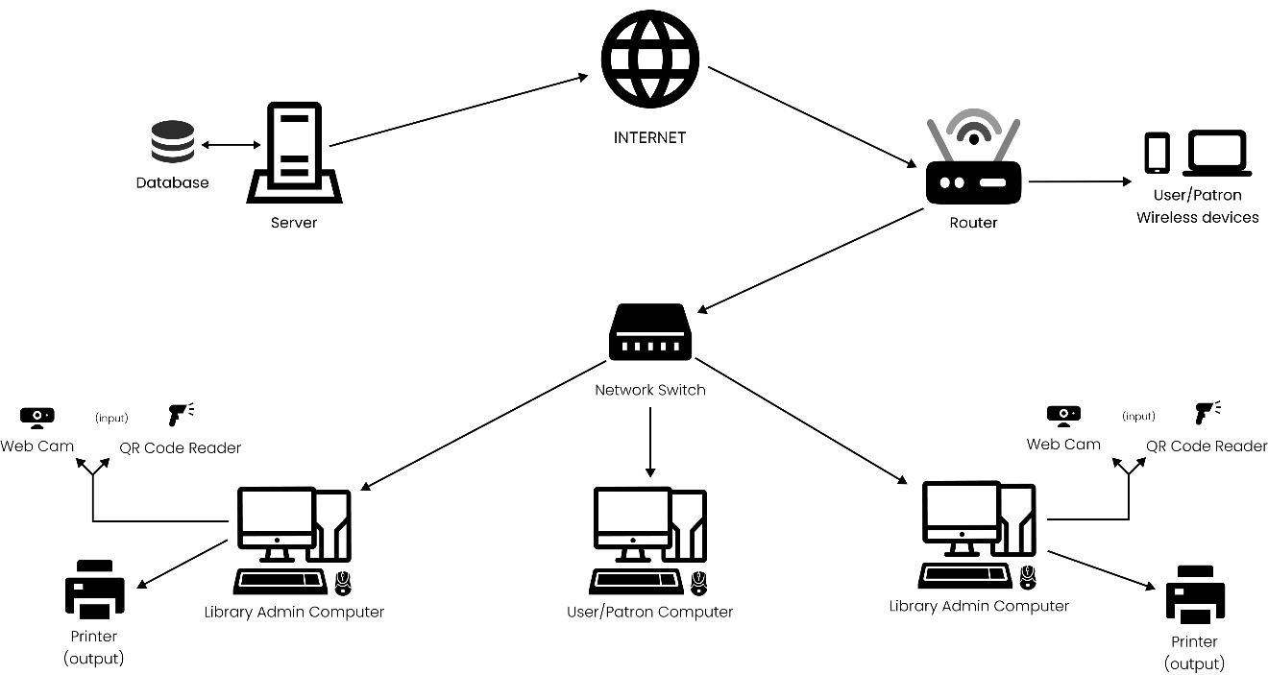

Figure 6.1 - Architectural Design

**Process Design**

This chapter delves into the intricacies of designing streamlined processes that optimize operational workflows and enhance decision-making capabilities within organizations. The integration of QR code scanning technology revolutionizes equipment tracking by providing swift and accurate access to critical information. QR codes serve as digital fingerprints, enabling seamless identification and retrieval of equipment data such as maintenance records, location tracking, and operational status. This real-time visibility empowers stakeholders to make informed decisions promptly, thereby minimizing downtime and optimizing resource allocation.

**Use Case Diagram**

The process and design chapter of a QR Code Scanning System with Informed Mechanism Driven Equipment Tracking System research includes a use case diagram illustrating user interactions with the system. It identifies roles such as finance, client, and administrators, and key functions like QR Code Equipment, View records, and user account management. This diagram clarifies system requirements and ensures essential functionalities are incorporated into the design.

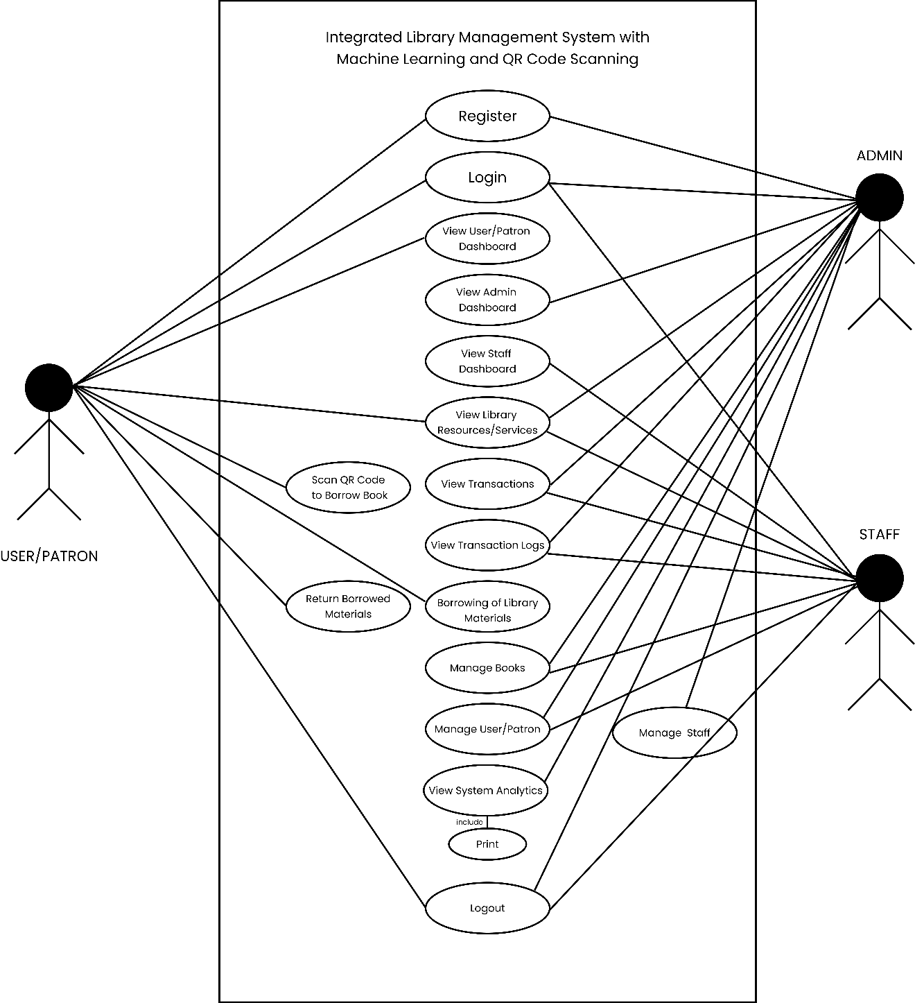

Figure 6.2 – Use Case Diagram

**DFD** (Data Flow Diagram)

The process and design chapter of an Integrated Library Management System (ILMS) research includes a Data Flow Diagram (DFD). The DFD illustrates the flow of information between modules like user management, cataloging, circulation, and reporting, highlighting data sources, storage, and user interactions. This diagram ensures efficient data handling and identifies areas for optimization.

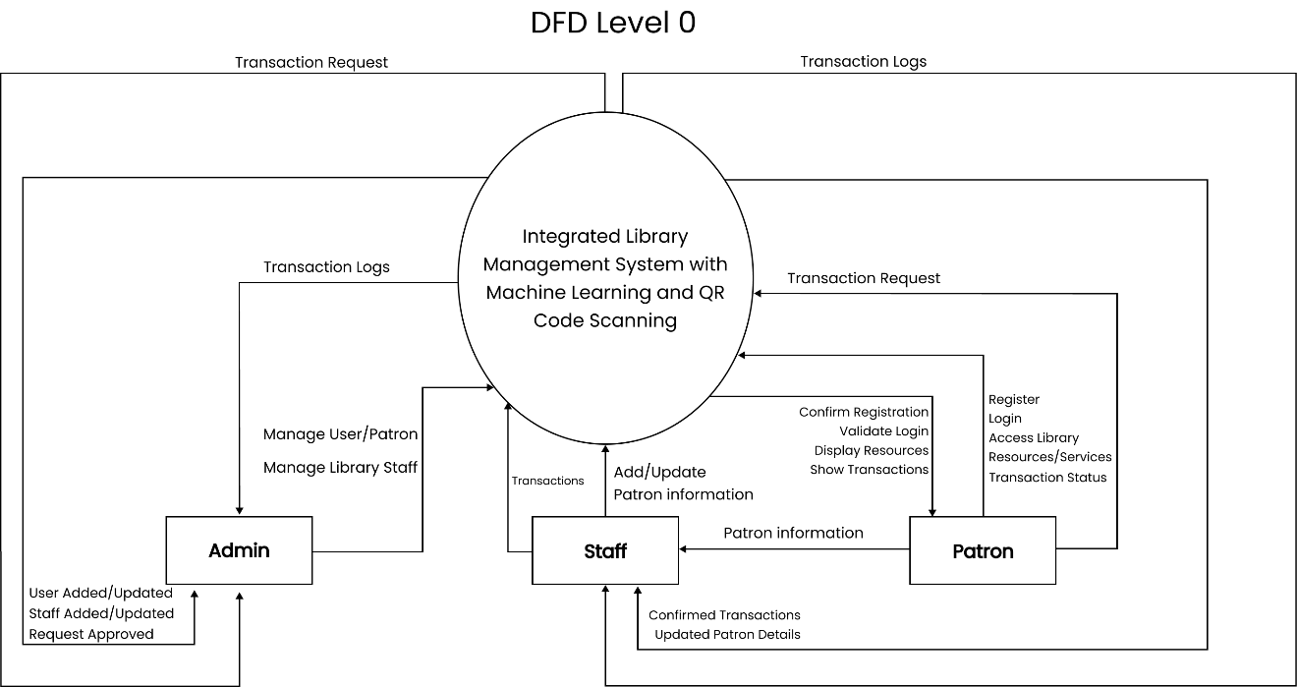

Figure 6.3 – DFD (Context Flow Diagram)

**ERD** (Entity Relationship Diagram)

The process and design chapter of an Integrated Library Management System (ILMS) research includes an Entity-Relationship Diagram (ERD). The ERD depicts the system's entities—such as books, users, and transactions—and their relationships, ensuring an accurate and efficient database design.

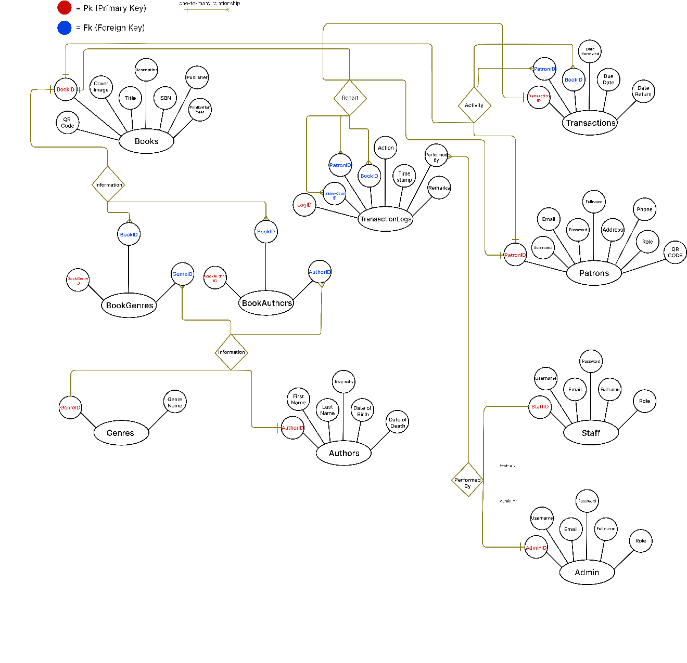Figure 6.4 – ERD (Entity Relationship Diagram)

**Database Design**

The database design section in the process and design chapter of an Integrated Library Management System (ILMS) research outlines the schema, defining tables for entities like books, users, and transactions, along with their relationships. This ensures data integrity, supports efficient queries, and ensures smooth system functionality.Admin

|  |  |
| --- | --- |
| NAME | DEFINITION |
| EMPLOYEE ID | Unique identifier for admin this is the (primary key) |
| FULL NAME | Full name of the admin |
| EMAIL | Active admin email used for notifications or communication |
| PASSWORD | Password use by the admin |
| ROLE | To identify that the user is an admin |

Staff

|  |  |
| --- | --- |
| NAME | DEFINITION |
| STAFF ID | Unique identifier for staff this is the (primary key) |
| FULLNAME | Full name of the staff |
| EMAIL | Active staff email use for notifications or communication |
| PASSWORD | Password use by the staff |
| ROLE | To identify that the user is staff |

User/Patron

|  |  |
| --- | --- |
| NAME | DEFINITION |
| PATRON ID | Unique identifier for user/patrons this is the (primary key) |
| USERNAME | Username of the user/patron |
| EMAIL | Email address of the user/patrons |
| PASSWORD | Password use by the user/patrons |
| FULLNAME | Full name of the user/patron |
| ADRESS | Place where the user/patron lives |
| PHONE NUMBER | The patron or user's active phone number |
| ROLE | To identify that the user is patron/user |
| QR CODE | A Quick Response code that can store data such as URLs or text, readable by a QR scanner or smartphone camera, used for quick access to user-specific information. |

Transaction

|  |  |
| --- | --- |
| NAME | DEFINITION |
| TRANSACTION ID | Unique identifier for record (primary key) |
| PATRON ID | Identifier for the patron borrowing the book (foreign key) |
| BOOK ID | Identifier for the borrowed book (foreign key) |
| DATE BORROWED | Date when the book was borrowed |
| DUE DATE | Date by which the book should be returned |
| DATE RETURNED | Date when the book was returned |

Books

|  |  |
| --- | --- |
| NAME | DEFINITION |
| BOOK ID | Unique identifier for each book (primary key) |
| TITLE | Title of the book |
| ISBN | International Standard Book Number |
| PUBLICATION YEAR | The year the book was published |
| PUBLISHER | Name of the publishing company |
| DESCRIPTION | A brief summary or description of the book |
| COVER IMAGE | Link to or file path of the cover image of book |
| QR CODE | A Quick Response code that can store data such as URLs or text, readable by a QR scanner or smartphone camera, used for quick access to user-specific information. |

Genres

|  |  |
| --- | --- |
| NAME | DEFINITION |
| GENRE ID | Unique identifier for each genre (primary key) |
| GENRE NAME | Name of the genre |

Authors

|  |  |
| --- | --- |
| NAME | DEFINITION |
| AUTHOR ID | Unique identifier for each author (primary key) |
| FIRST NAME | First names of the authors |
| LASTNAME | Last name of the authors |
| BIOGRAPHY | Short biography of the author |
| DATE OF BIRTH | Date of birth of the author |
| DATE OF DEATH | Date of death of the author |

Book Authors

|  |  |
| --- | --- |
| NAME | DEFINITION |
| BOOK AUTHOR ID | Unique identifier for each book author (primary key) |
| BOOK ID | Identifier for a specific book (foreign key) |
| AUTHOR ID | Identifier for a specific author (foreign key) |

Book Genres

|  |  |
| --- | --- |
| NAME | DEFINITION |
| BOOK GENRE ID | Unique identifier for each book genre (primary key) |
| BOOK ID | Identifier for a specific book (foreign key) |
| GENRE ID | Identifier for a specific genre (foreign key) |

Transaction Log

|  |  |
| --- | --- |
| NAME | DEFINITION |
| LOG ID | Unique identifier for each log entry (primary key) |
| TRANSACTION ID | Identifier for the related transaction |
| PATRON ID | Identifier for the patron involved in the transaction |
| BOOK ID | Identifier for the book involved in the transaction |
| ACTION | Description of the action (e.g., borrowed, returned) |
| TIMESTAMP | Date and time when the action was performed |
| PERFORME BY | Person who performed the action |
| REMARKS | Additional remarks |

**Normalization**

Admin

|  |  |
| --- | --- |
| admin | |
| AdminID | 1 |
| FullName | Admin User |
| Email | admin@gmail.com |
| Password | Adminpassword1 |
| Role | Admin |

Staff

|  |  |
| --- | --- |
| staff | |
| StaffID | 1 |
| fullname | Alice Smith |
| email | Alice.smith@gmail.com |
| password | Password1 |
| role | staff |

User/Patron

|  |  |
| --- | --- |
| patrons | |
| PatronID | 1 |
| username | John doe |
| email | johndoe@gmail.com |
| password | password123 |
| fullname | John Doe |
| address | 123 Main St |
| phone | 555-1234 |
| role | Patron |
| QRCode | /path/to/qrcodes/johnDoe_qr.png |

Transaction

|  |  |
| --- | --- |
| transaction | |
| TransactionID | 1 |
| PatronID | 1 |
| BookID | 1 |
| DateBorrowed | 2023-05-01 |
| DueDate | 2023-05-15 |
| DateReturn | NULL |

Books

|  |  |
| --- | --- |
| books | |
| BookID | 1 |
| Title | Book 1 |
| ISBN | 978-0-123456-78-9 |
| PublicationYear | 2022 |
| Publisher | Publisher A |
| Description | Description of Book 1 |
| CoverImage | book1.jpg |
| QRCode | /path/to/qrcodes/book1_qr.png |

Genres

|  |  |
| --- | --- |
| genres | |
| GenreID | 1 |
| GenreName | Fiction |

Authors

|  |  |
| --- | --- |
| authors | |
| AuthorID | 1 |
| FirstName | John |
| LastName | Doe |
| Biography | Biography of John Doe |
| DateOfBirth | 1975-01-01 |
| DateOfDeath | 2020-05-15 |

Book Authors

|  |  |
| --- | --- |
| book author | |
| BookAuthorID | 1 |
| BookID | 1 |
| AuthorID | 1 |

Book Genres

|  |  |
| --- | --- |
| bookgenres | |
| BookGenreID | 1 |
| BookID | 1 |
| GenreID | 1 |

Transaction Log

|  |  |
| --- | --- |
| transactionlog | |
| LogID | 1 |
| TransactionID | 1 |
| PatronID | 1 |
| BookID | 1 |
| Action | Borrowed |
| Timestamp | 2024-05-22 14:49:58 |
| PerformedBy | 1 |
| Remarks | Borrowed via QR code scanning |

**Physical Structure**

admin

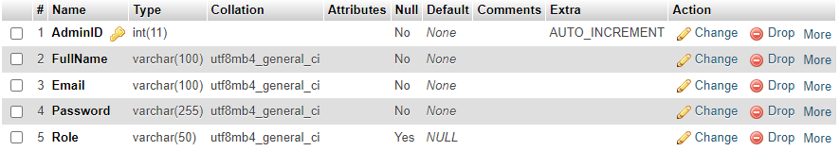

Figure 6.5

authors

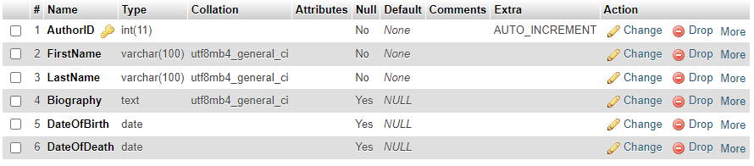

Figure 6.6

bookauthors

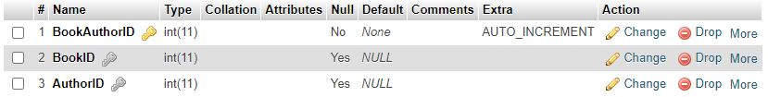

Figure 6.7

bookgenres

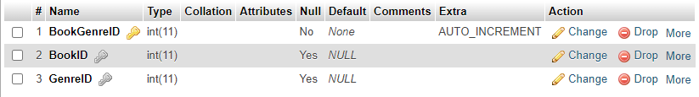

Figure 6.8

books

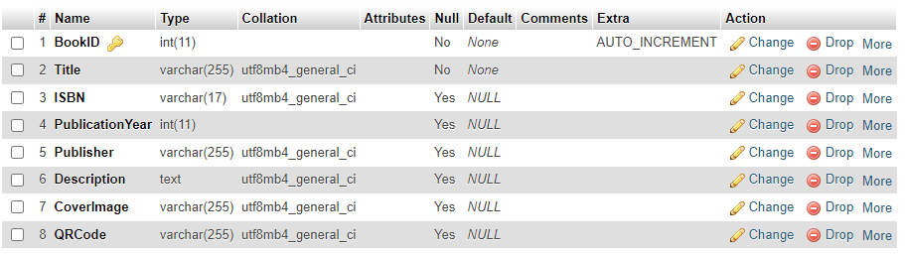

Figure 6.9

genres



Figure 6.10

patrons

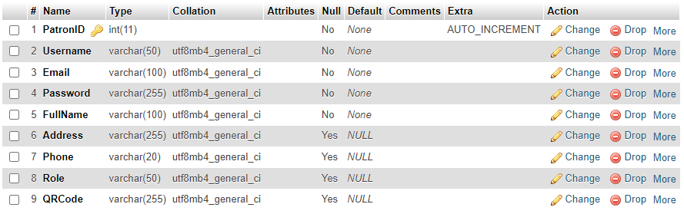

Figure 6.11

staff

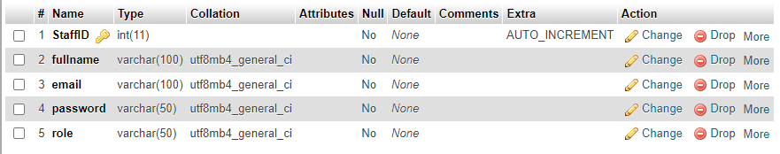

Figure 6.12

transactionlogs

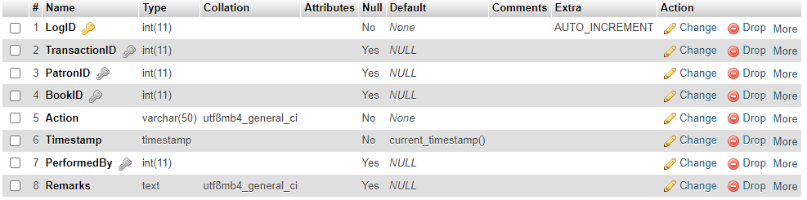

Figure 6.13

transaction

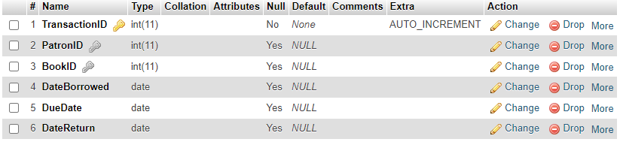

Figure 6.14

**Prototype Design**

The process and design chapter of an Integrated Library Management System (ILMS) research includes a section on prototype design. This outlines the creation of an initial version of the ILMS, facilitating testing and feedback to ensure the final system meets user requirements effectively.

**GUI**

**Admin**

**Login**

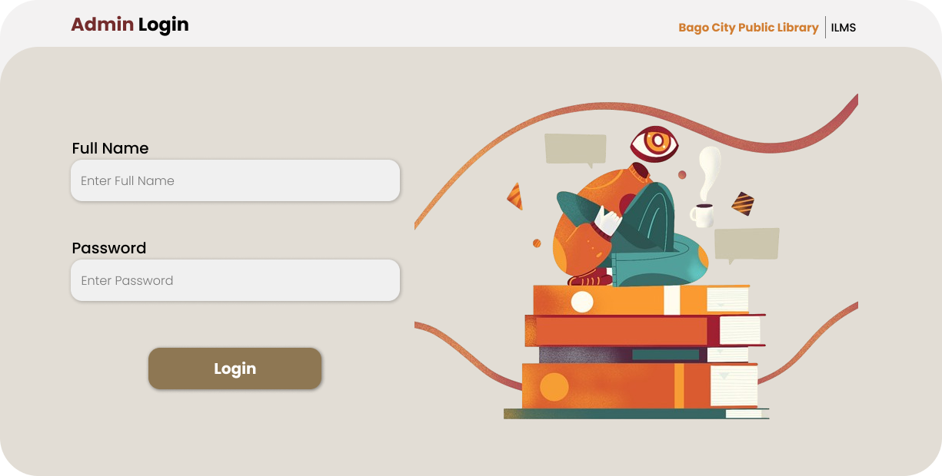

Figure 6.15

**Admin Dashboard**

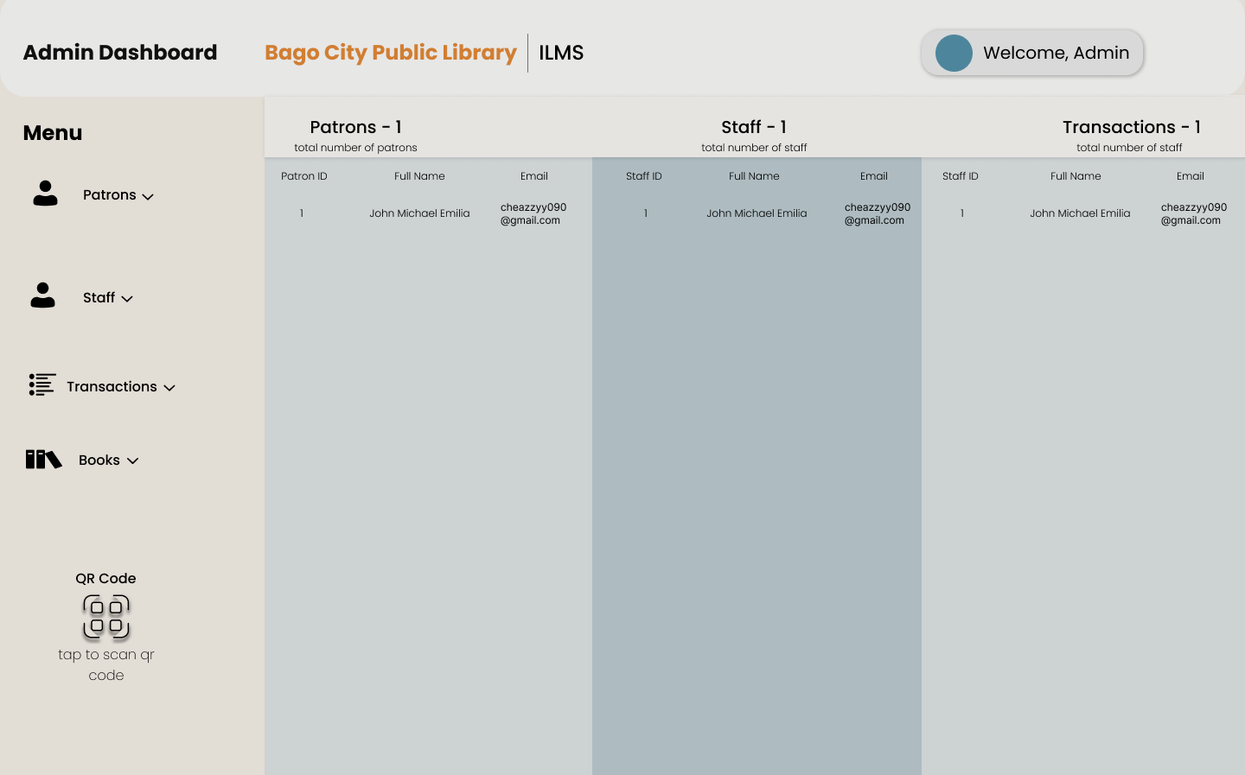

Figure 6.16

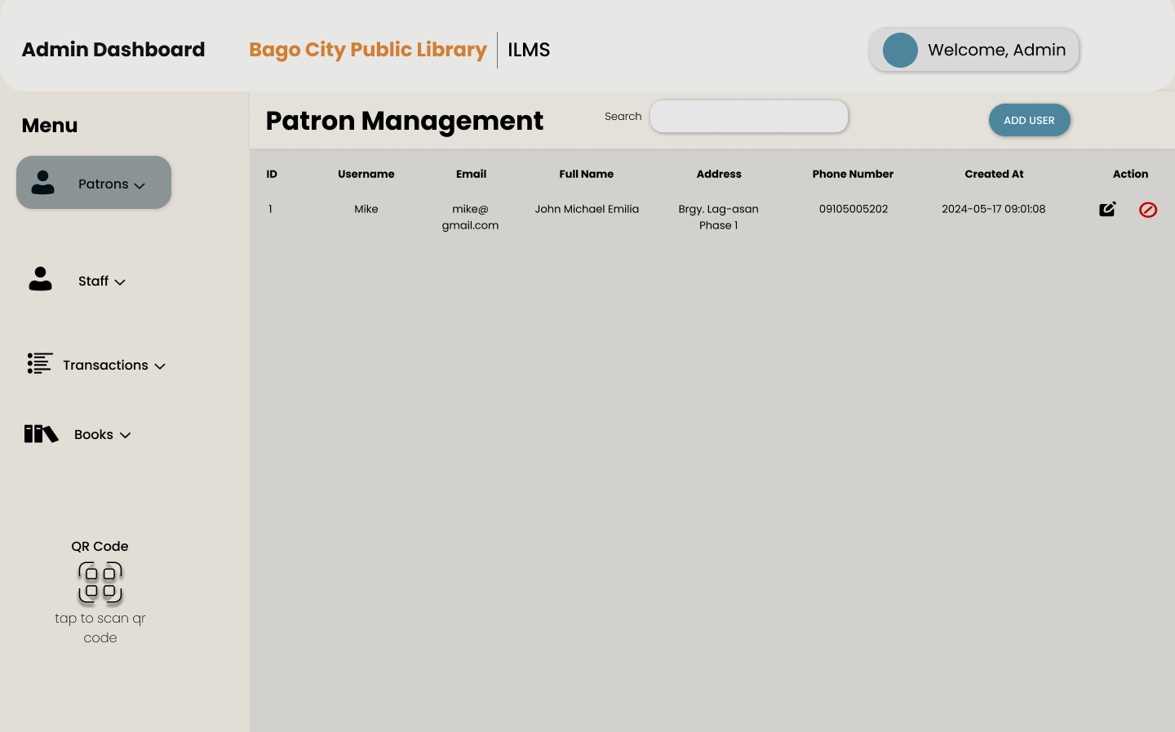

Figure 6.17

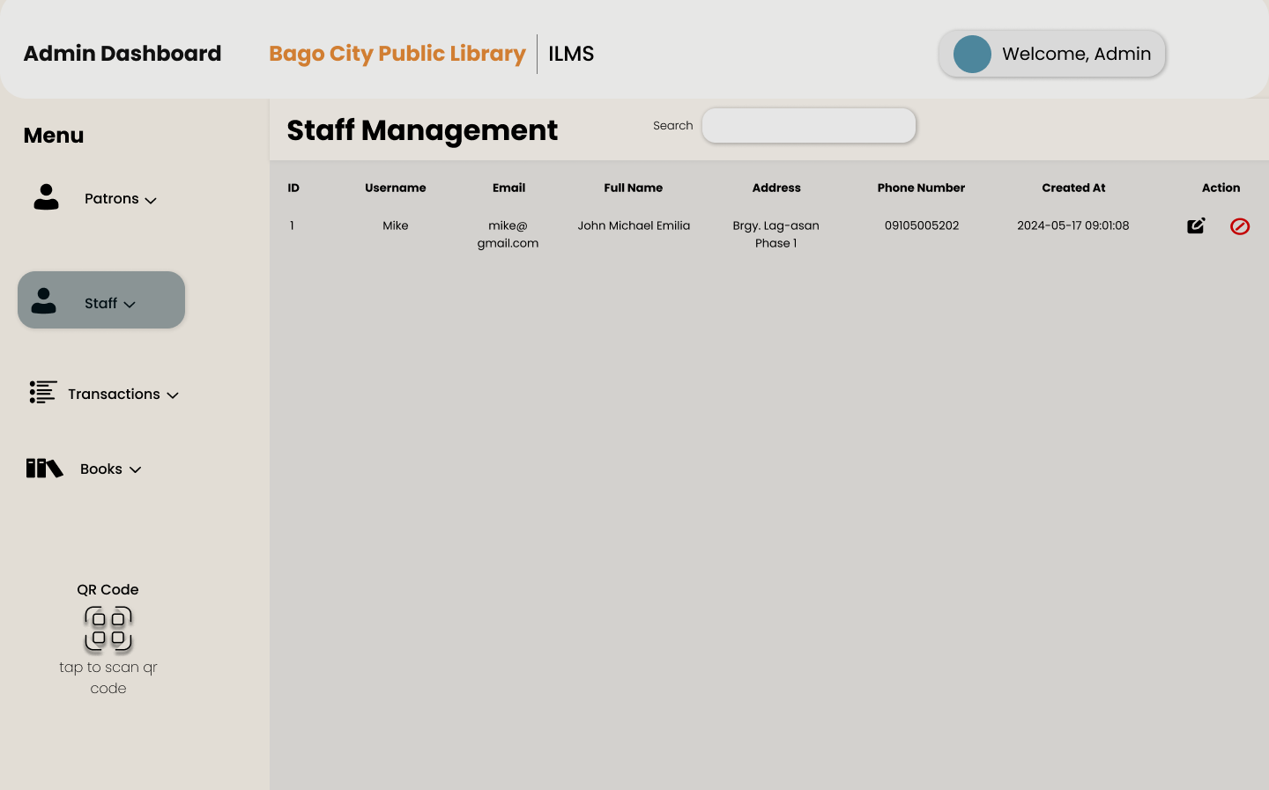

Figure 6.18

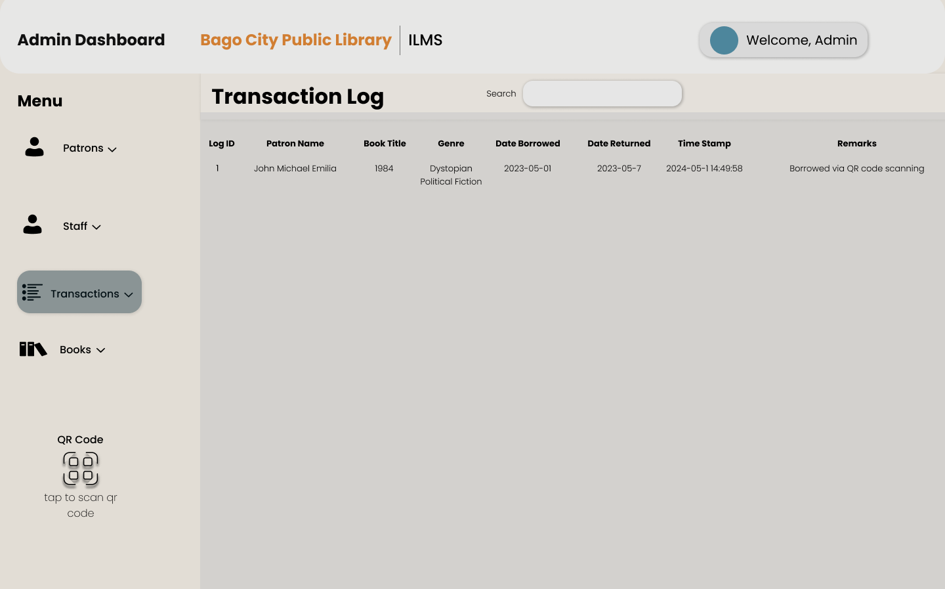

Figure 6.19

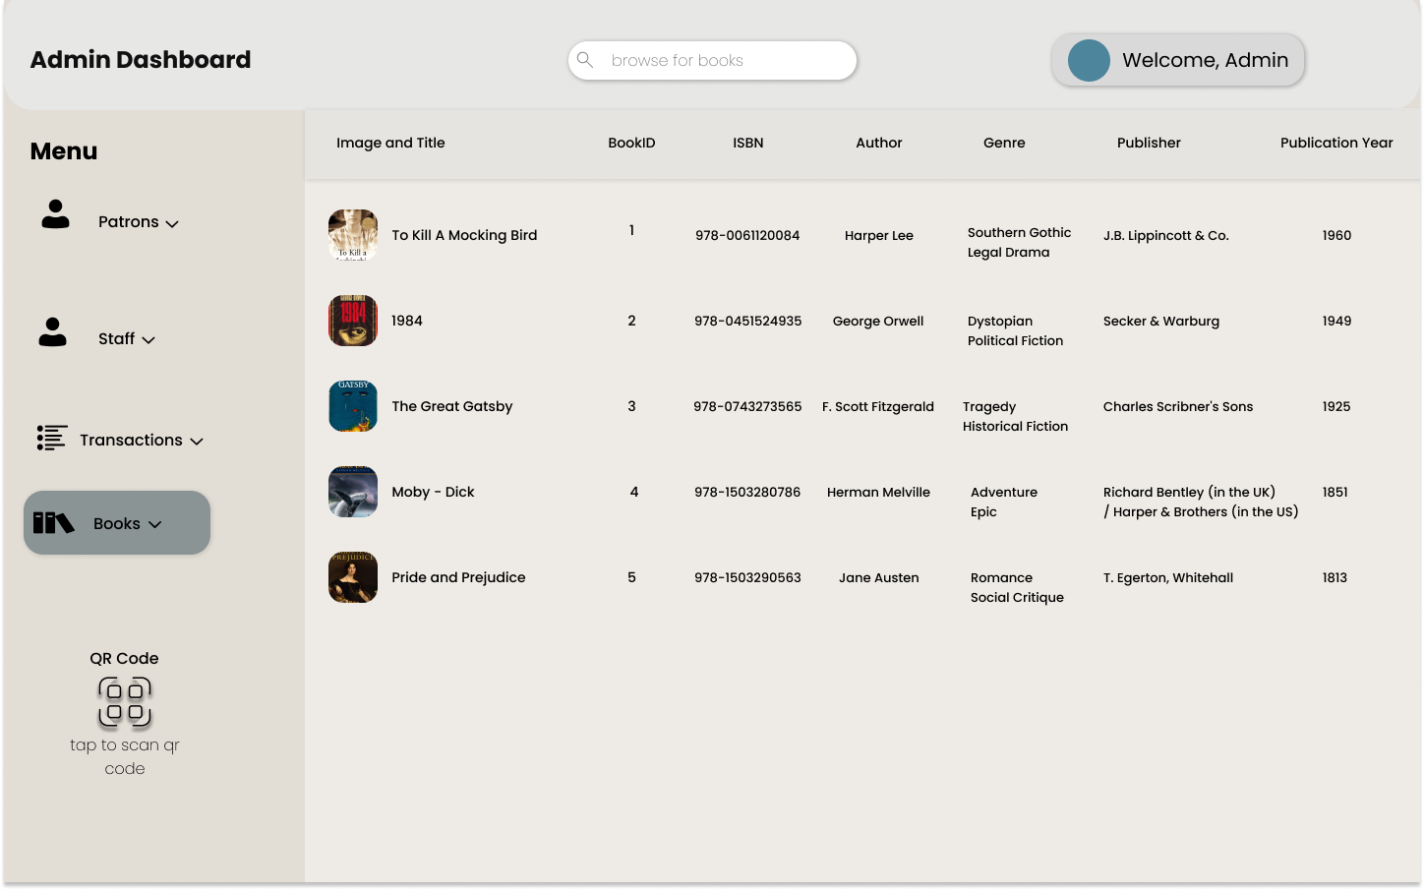

Figure 6.20

**Staff  
Login**

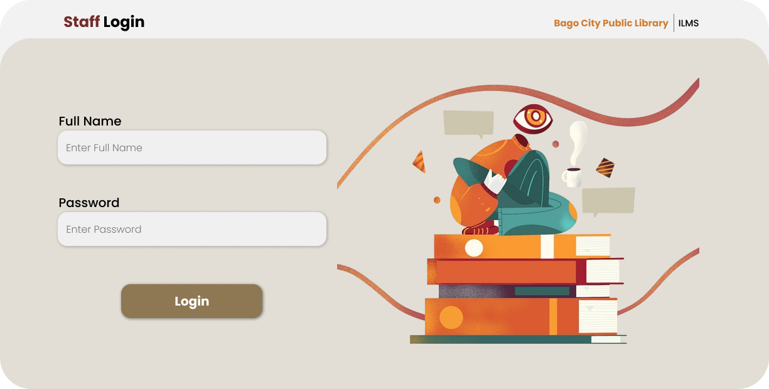

Figure 6.21

**Staff Dashboard**

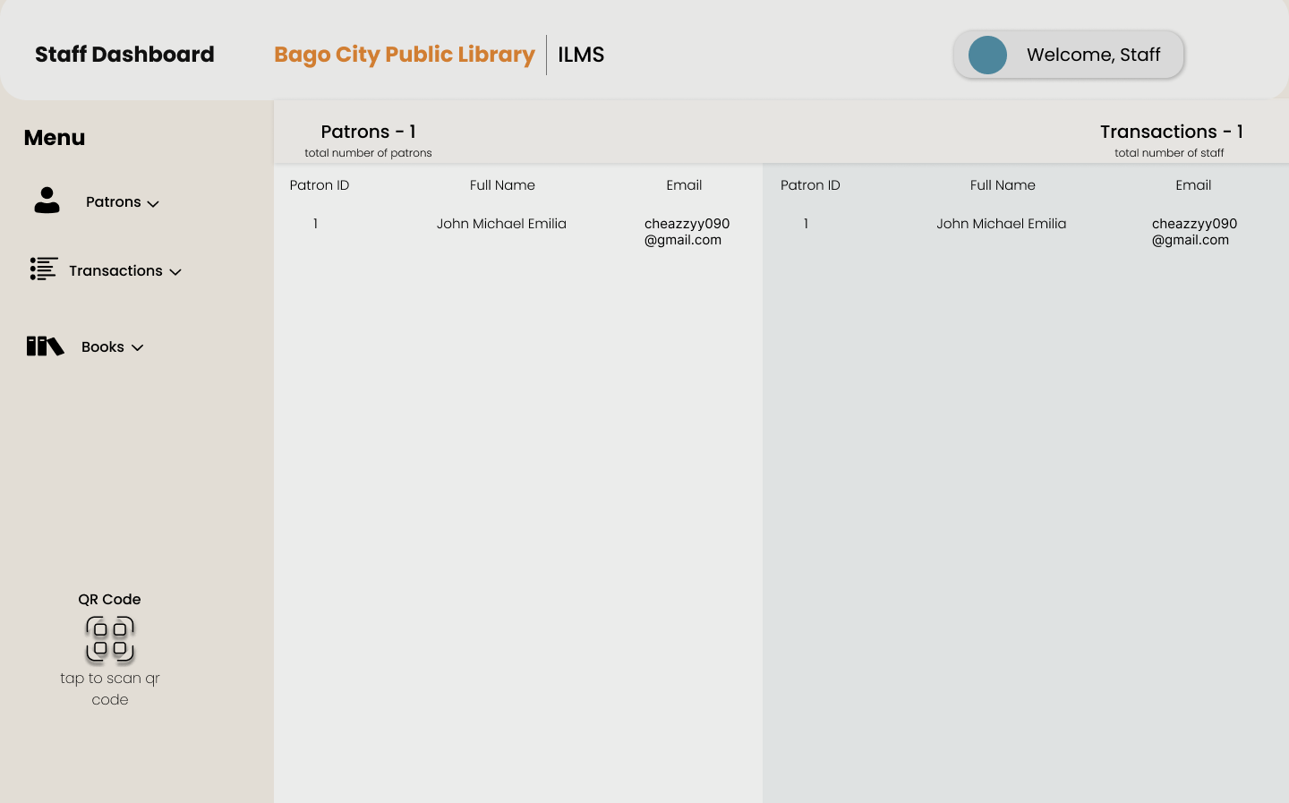

Figure 6.22

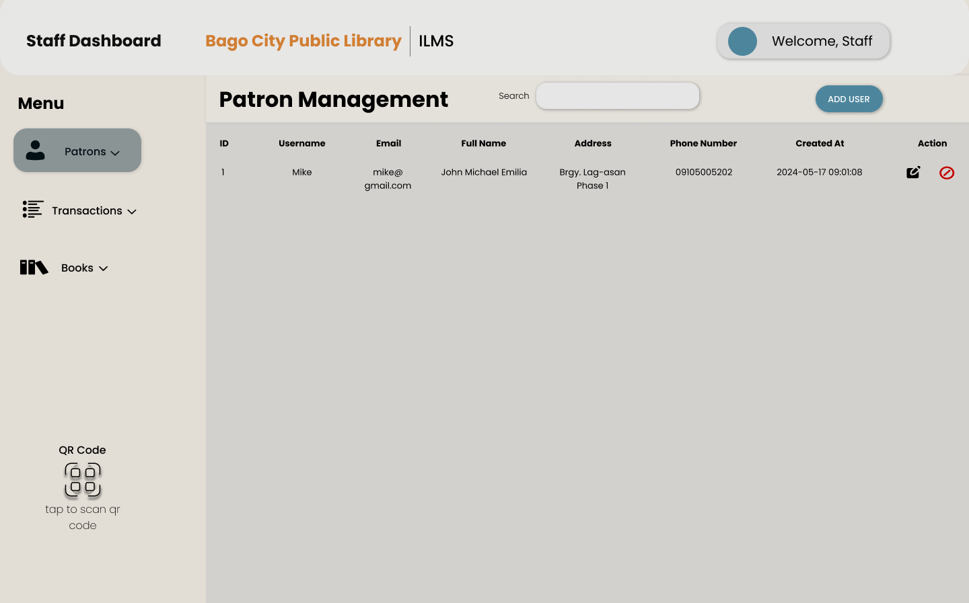

Figure 6.23

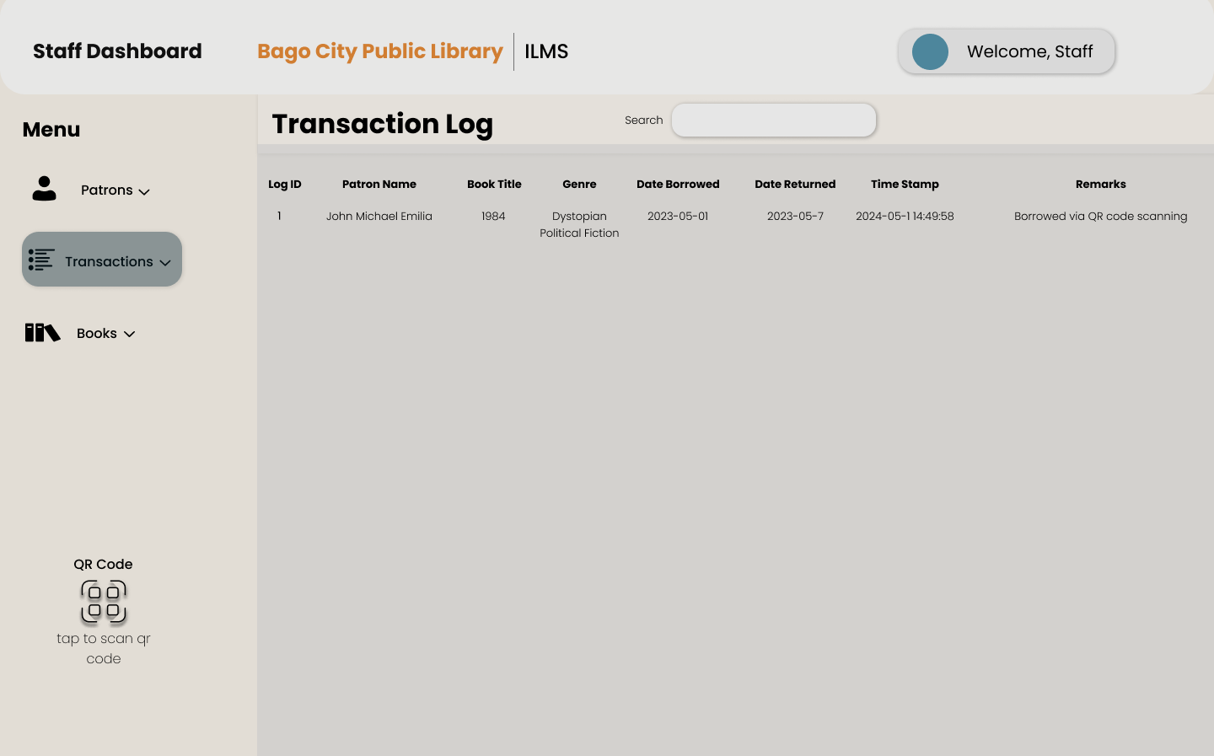

Figure 6.24

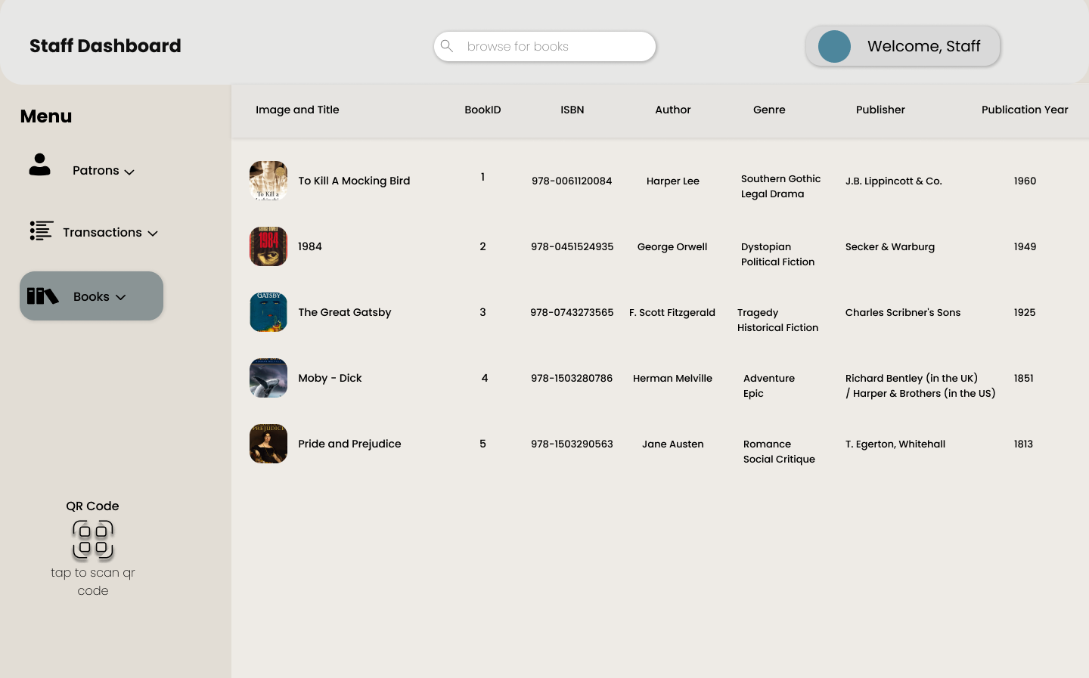

Figure 6.25

**User/Patron**

**Sign Up**

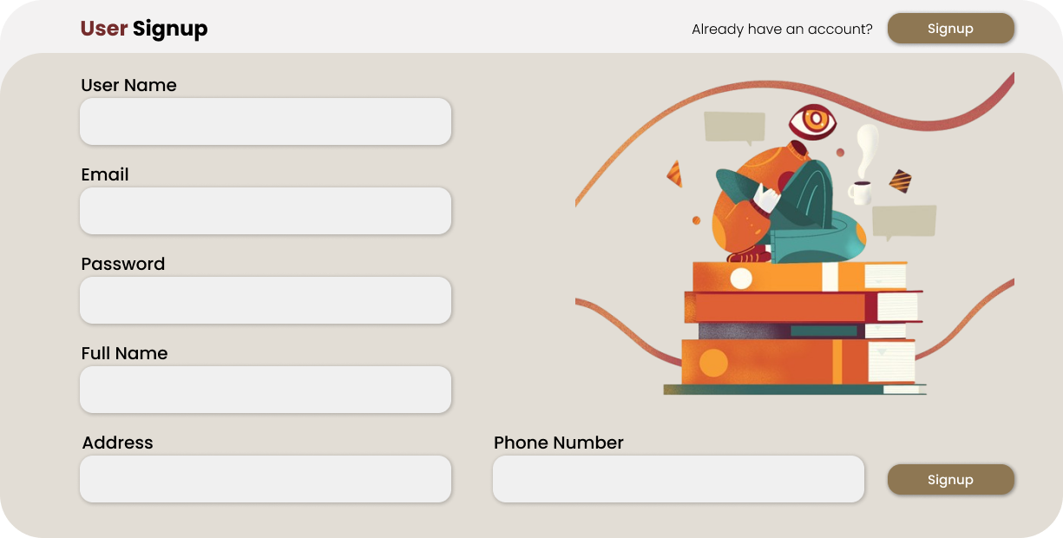

Figure 6.25

**Login**



Figure 6.26

**User/Patron**

**Dashboard**



Figure 6.27

**Account**

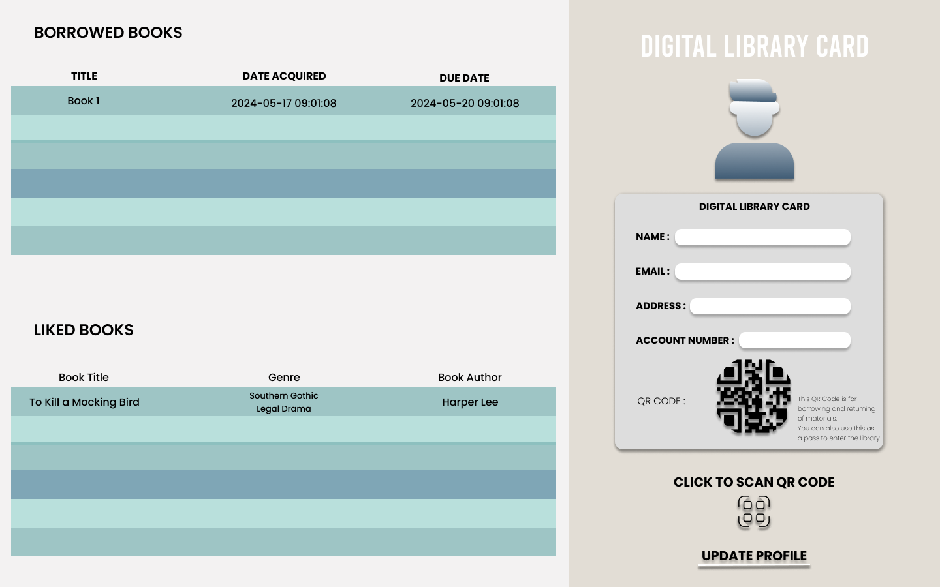

Figure 6.28

**CHAPTER VII**

**PRESENTATION, ANALYSIS AND INTERPRETATION OF DATA**

The purpose of this chapter is to present the collected data, analyze the findings, and interpret the results in the context of the study's objectives regarding the integrated library management system with machine learning and QR code scanning. This chapter is crucial as it provides an in-depth examination of the information gathered from various sources, including user feedback, expert evaluations, and system performance metrics, to evaluate the effectiveness of the developed system in real-world library environments.

The data presentation involves systematically organizing and displaying the collected information using tables, charts, and other visual aids to enhance clarity. The analysis section identifies patterns, correlations, and key findings that align with the study’s goals. Finally, the interpretation discusses the implications of these findings, relating them back to the research questions and objectives. By addressing each aspect of the data, this chapter aims to provide a comprehensive understanding of the system's performance and its alignment with the defined objectives. These insights will form the basis for the conclusions and recommendations in the final chapter.

Table 3 presents the scoring rubric used to determine the level of satisfaction of library users with the integrated library management system that incorporates machine learning and QR code scanning capabilities.

|  |  |  |
| --- | --- | --- |
| Numerical Rating (Mean Range) | Qualitative Rating | Verbal Description |
| 3.25 - 4.00 | Very Satisfied (VS) | The developed system fully meets the objectives of the study. |
| 2.50 - 3.24 | Satisfied (S) | The developed system meets some objectives of the study. |
| 1.75 - 2.49 | Dissatisfied (D) | The developed system does not meet some objectives of the study. |
| 1.00 - 1.74 | Very Dissatisfied (VD) | The developed system does not meet any objectives of the study. |

Table 4 presents the scoring rubric used to evaluate the technical qualifications of the integrated library management system by IT experts and professionals.

|  |  |  |  |
| --- | --- | --- | --- |
| General Objective | Numerical Rating (Mean Range) | Qualitative Rating | Verbal Description |
| . Implement a machine learning model to enhance search capabilities and book recommendations based on user behavior. | 3.25 - 4.00 | Very Satisfied (VS) | The developed system fully meets the objectives of the study. |
| 2. Integrate QR code scanning for fast and secure book check-in/check-out processes. | 2.50 - 3.24 | Satisfied (S) | The developed system meets some objectives of the study. |
| 3. Reduce the time required for catalog management and inventory tracking through automation. | 1.75 - 2.49 | Dissatisfied (D) | The developed system does not meet some objectives of the study. |
| 4. Provide detailed analytics and reports on library usage, book popularity, and user engagement. | 1.00 - 1.74 | Very Dissatisfied (VD) | The developed system does not meet any objectives of the study. |

The following are the results of the study based on the collected and tabulated data.

**Table 5** presents the responses from the perceived users of the integrated library management system, evaluated against general objectives. These objectives include: 1) Designing a system to enhance search capabilities and book recommendations using machine learning, 2) Integrating QR code scanning for efficient book check-in/check-out, 3) Automating catalog management and inventory tracking, and 4) Generating detailed reports on library usage and user engagement. The results show high satisfaction, with mean scores reflecting that the system effectively meets all these objectives. **Table 6**

Table 5 below, (System Users) result Shows the Mean and Standard deviation values and interpretation.

|  |  |  |  |  |
| --- | --- | --- | --- | --- |
| Objective | Mean | Standard Deviation | Description | Interpretation |
| 1. | 3.70 | 0.46 | VS | The developed system has answered all the objectives of the study. |
| 2. | 3.40 | 0.49 | VS | The developed system has answered all the objectives of the study. |
| 3. A  B  C | 3.60  3.80  3.80 | 0.49  0.40  -0.40 | VS | The developed system has answered all the objectives of the study. |
| OVER-ALL MEAN | 3.68 | - | VS |  |

|  |  |  |  |  |
| --- | --- | --- | --- | --- |
| Software Characteristic | Sub-characteristic | Numerical Rating (Mean Range) | Qualitative Rating | Verbal Description |
| Functional Suitability | A. Completeness, B. Appropriateness, C. Correctness | 3.25 - 4.00 | VS | The developed system fully meets the objectives of the study. |
| Performance Efficiency | A. Time Behavior, B. Resource Utilization, C. Capacity | 2.50 - 3.24 | S | The developed system fully meets the objectives of the study. |
| Compatibility | A. Coexistence, B. Interoperability | 1.75 - 2.49 | D | The developed system fully meets the objectives of the study. |
| Usability | A. Appropriateness recognizability, B. Learnability, C. Operability, D. User error protection, E. User interface aesthetics, F. Accessibility | 1.00 - 1.74 | VD | The developed system fully meets the objectives of the study. |
| Reliability | A. Maturity, B. Availability, C. Fault tolerance, D. Recoverability | 3.25 - 4.00 | VSS | The developed system fully meets the objectives of the study. |
| Security | A. Confidentiality, B. Integrity, C. Non-repudiation, D. Accountability, E. Authenticity | 2.50 - 3.24 | S | The developed system fully meets the objectives of the study. |
| Maintainability | A. Modularity, B. Reusability, C. Analyzability, D. Modifiability, E. Testability | 1.75 - 2.49 | D | The developed system fully meets the objectives of the study. |
| Portability | A. Adaptability, B. Instability, C. Replaceability | 1.00 - 1.74 | VD | The developed system fully meets the objectives of the study. |

**CHAPTER VIII**

**SUMMARY, CONCLUSION AND RECOMMENDATION**

The evaluation results presented in this chapter demonstrate the effectiveness of the integrated library management system with machine learning and QR code scanning. The user feedback, summarized in Table 5, indicates that the system has successfully achieved its objectives, with an overall mean score of 3.68. This rating, falling within the range of 3.25 – 4.00, reflects a high level of user satisfaction, highlighting the system's success in enhancing library services.

In assessing the system against the ISO/IEC 25010:2011 standards, Table 6 reveals that IT experts rated the system with an overall mean of 3.80. This score, described as Very Good, signifies that the system meets international software quality standards effectively.

Both user and expert evaluations confirm that the system not only fulfills user needs but also aligns with global quality benchmarks. The results support the recommendation for the system's implementation in library operations.

For further enhancement, it is suggested to incorporate additional security measures. This includes implementing procedures for secure data handling and regular monitoring to protect against potential threats. Additionally, maintaining robust backup protocols and enhancing user support can further improve the system’s reliability and user experience.